“We don’t want to bring to Milwaukee the southland’s Jim Crowism”: Racialized Urban Development in Milwaukee, 1910–1968

Charles Roth
December 9, 2025
HIS 480: Senior Research Seminar
Dr. Tova Benjamin, Dr. Meghna Chaudhuri, and Dr. Jakub Kabala

Introduction
In the evening of 9 October 1944, the Milwaukee Common Council held a hearing regarding the future of properties in the city outskirts. Months earlier on July 31, Alderman August J. Abe had maneuvered a resolution through the Council using the loophole of suspended rules when the body was not officially in session. This Resolution, which came to be called the Abe Resolution, moved to allow the City Real Estate Authority to acquire plots and houses in a suburban area called “Carlton’s Addition” to build a playground. It mobilized the city’s right to eminent domain to push for this playground, when in fact the underlying reason for making Carlton’s Addition into a civic public place was to prevent the sale of lots and homes to potential Black buyers. It was no coincidence that requests for building the playground had only begun after eighteen Black families purchased properties in Carlton’s Addition. Neighboring residents were attempting to leverage municipal government power to keep their community all-white. The hearing attracted Milwaukeeans both for and against the Resolution. The divided chamber consisted of twenty-five Black residents and other representatives objecting to the measure and one-hundred-and-fifty white residents in support of replacing the Black-owned plots with a forty-acre playground.
Bernice Copeland-Lindsay, secretary of the Black Young Women’s Christian Organization (YWCA), gave her testimony against the Resolution. She was among the African Americans who hoped to live in Carleton’s Addition. They were trying to move out of the city center, with its deteriorating housing. Able to afford such a move, the Black families had identified accessible space in the city outskirts. When Copeland-Lindsay mentioned that she “could afford to live in the area,” the mass of white residents heckled at her. The chamber broke out in an unruly exchange of words, and she was joined by other speakers objecting to the measure. Racial hostility peaked when George Bradow, the white Congress of Industrial Organizations (CIO) representative, emphasized how Black people were forced to live in deteriorating residences in the inner-city Third and Sixth Wards. Supporters of the Resolution continued shouting insults and booing, chanting “Sit down” and “Throw him out.” Shocked by the display of white tribalism, Bradow pronounced that “You can expect such [Jim Crow] lynch atmosphere under the circumstances.”
James W. Dorsey, representing the Milwaukee National Association for the Advancement of Colored People (NAACP), critiqued the motives for proposing a playground to be built in Carlton’s Addition. Though he was generally in support of public works intended to improve life in Milwaukee, he observed that “had it not been for the fact that Negroes had built in the area, there would have been no immediate desire for this project.” Dorsey cautioned that the Resolution would set the precedent of government-sponsored racial segregation in the Northern city. The issue was not just a playground. It signified something far more and he urged the Common Council to be cognizant of how the battle over Carlton’s Addition was about much more than the neutral allocation of civic space: “We don’t want to bring to Milwaukee the southland’s Jim Crowism principles,” he warned.
Dorsey’s discomfort about the potential transplanting of Southern Jim Crow laws and institutionalized racial segregation in Milwaukee reverberates nearly a century later. In the 21st century, Milwaukee is one of the most segregated cities in the United States. Cartographers have mapped data from the 2020 national census to show racial and ethnic patterns in residency (See figure 1, page 4). Representing each surveyed person with one dot, all dots were color-coded based on race and ethnicity. The map shows dots representing white people as brown, Black or African-American people as yellow, and Hispanic or Latino people as turquoise. Looking at racial and ethnic patterns in residency in 2020 Milwaukee, a color line sharply separates predominately white communities like Shorewood, Whitefish Bay, and Wauwatosa from Black neighborhoods in northwest Milwaukee. Northern cities like Milwaukee are often overlooked in histories of racial segregation in the United States, while the American South receives the most attention from popular retellings of the Civil Rights Movement.
The intensity of the racial divide in the 2020s begs the question: How did Milwaukee become so segregated? From 1910 to 1968, racialized urban development in Milwaukee coalesced into the durable segregation that persists into the 21st century. Mechanisms such as labor exclusion, economic zoning, racially restrictive covenants, redlining, segregated public housing, municipal resolutions, weak race relations committees, whites-only veterans’ benefits, blockbusting, and discriminatory policing bolstered segregated urban structures. I focus on race relations in the pivotal wartime moment from 1940 to 1944 in Milwaukee to unpack a key moment of racial tension around housing. This moment is against the backdrop of segregation and its politics more broadly in the American Midwest and industrial North.
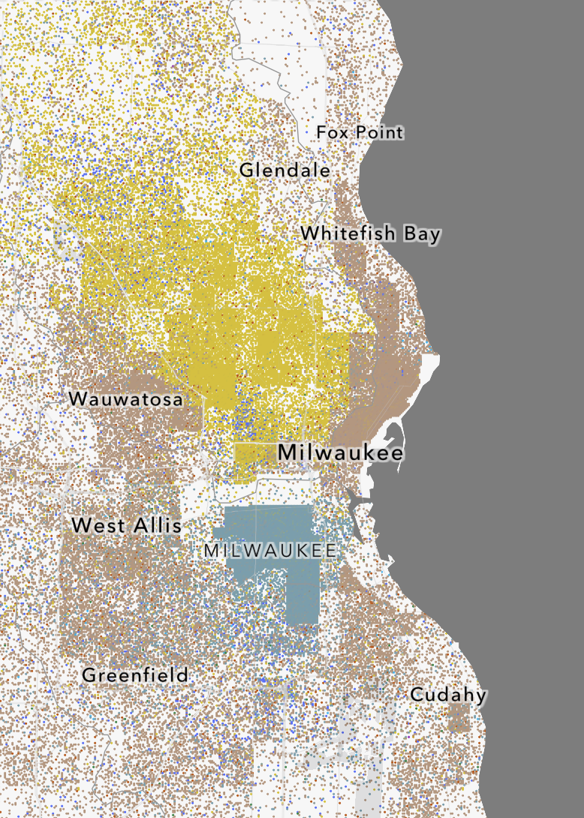
Figure 1: Map of Milwaukee with racial and ethnic data from the 2020 Census. Each dot represents
one person, and its color represents their race and ethnicity: brown is white, yellow is Black or
African-American, and turquoise is Hispanic or Latino.

Scholars characterized souring race relations in Milwaukee in the 1940s. Milwaukee, however, was not contextualized enough within the national moment of racial hostility and racialized urbanism from 1940 to 1944. Racial confrontations in institutional settings like the one this paper opened with can be better understood in relation to other racialized disputes over contested urban spaces. Interrogating incidents of racial unrest in cities inside and outside the Midwest integrate Milwaukee into the nationwide structure excluding and segregating Black people. By examining local newspaper articles and the John L. Bohn Mayoral Records on Housing and the Committee on Inter-Racial Relations, I will position Milwaukee within national wartime and postwar racial history. Racialized urbanism and conflict from 1940–1944 shaped inequalities, policies, and race relations in Milwaukee for decades to come.
First, I analyze the history of race relations in Milwaukee and the United States from 1910 until the beginning of American involvement in World War II. Here, I cover racialized urban policies in Milwaukee like economic zoning, restrictive covenants, redlining, and segregated public housing. Second, I interrogate Milwaukee’s government response to race relations pressures from 1940 to 1944. In this wartime moment, nationwide unrest alongside local legal disputes involving race brought segregation and inequality to the forefront in Milwaukee. This moment was important because it modeled racialized urbanism, open housing advocacy, racial violence, and insufficient government action in following decades. Finally, I briefly conclude by framing how the 1940–1944 moment conditioned discriminatory practices, civil rights advocacy, and racial strife in Milwaukee until the passing of the Fair Housing Act in 1968.
Weaving together the history of racialized urbanism is an important step toward efforts to realize solutions to ongoing resonances of racial segregation in American cities. In the 21st century, the Midwest remains to be a catalyst of urban inequality and civil rights protest. Racialized public policies have resulted in tragic cases like the murders of Michael Brown in 2014 and George Floyd in 2020 by law enforcement. These incidents occurred in St. Louis and Minneapolis, both segregated Midwestern cities with histories of racialized urbanism. The history of segregation and racialized urban development in the Midwest remains a matter of political relevance and a worthy object of historical enquiry as entrenched inequalities persist.

Black Migration and Racialized Policies, 1910–1940
Racialized urbanism in Milwaukee must be understood amid the backdrop of Northern race relations. Race relations in the urban North greatly changed when the movement of African Americans from Southern states began during World War I. Because of manpower shortages and labor activism, industrial jobs in Northern cities opened during the war. Black people from the South wished to escape lynching, Jim Crow laws, and the limited economic opportunities. Black populations greatly increased in the North as more migrants arrived. As African-American urban populations grew, however, anti-Black antagonism amassed in the North.
As new ethnic groups moved into Milwaukee, previous immigrant communities had established political power in the city. Migrant groups such as the Germans and Polish moved into larger and more expensive houses in developing suburbs like Shorewood, Wauwatosa, and the South Side. New arrivals lived in those groups’ former, lesser-quality dwellings. Specific neighborhoods, and certainly the move into developing suburbs signified social class for both existing residents and new migrants. When Black migrants moved into Milwaukee, they were largely restricted to living in the Third and Sixth Wards of the city center. Although white people made up half of the population of these wards, the area became known as the Black district following the increase of African-American residents. Due to racial exclusion, however, Black Milwaukeeans did not have the same privileges as European migrants in social mobility and advancing their housing situation.
Across Northern cities, the demographic shift of African-American residents moving out of historic Black quarters into previously all-white neighborhoods was an important factor in motivating white resentment and violence. In the summer of 1919, race relations nationwide turned bloody. The most widely reported “race riot” occurred in Chicago. In the riot, white mobs damaged houses and hunted people in Black neighborhoods. In response, Black World War I veterans shot at white rioters for protection. The riot ended with thirty-eight deaths: fifteen white and twenty-three Black, in addition to over five-hundred people injured. As seen in Chicago, white residents in the urban Midwest became hostile to Black people when they moved into all-white neighborhoods following the Great Migration.
The 1920s were a decade of contradictions: despite economic growth nationwide, workers went on strike regularly. Corporations sought to lower workers’ wages once World
War I ended. In response, working-class people used strategies like striking to prove their power in collective bargaining. Captains of industries, however, found ways to disarm strikers and dissuade future walkout plots. Companies hired strikebreakers to fill the vacant roles of protesting workers. As a result, striking laborers lost their jobs and the strike would capitulate. With the increase of African-American migrants looking for work, companies often hired Black people as strikebreakers to terminate labor activity. Black workers were often more competitive than white laborers since they could be paid less and were not unionized. White laborers began feeling resentment toward Black workers for helping thwart white collective bargaining power.
At times, this resentment escalated into anti-Black violence. One instance occurred in the periphery of Milwaukee. During the Great Railroad Strike of 1922, Chicago Northwestern Rail Road and Milwaukee Railway hired Black workers to replace those on strike. Housed inside boxcars in the Milwaukee outskirt New Butler, Black strikebreakers were ambushed with rounds of bullets from striking white workers. Following the Great Migration, labor disputes often precipitated into racial hostility and violence in Milwaukee.
With more African Americans in Northern cities, white residents and policymakers looked for ways to restrict Black access to white spaces and opportunities. Northern cities, however, could not enact explicit segregating ordinances. In 1917, the United States Supreme Court prohibited ordinances explicitly enforcing residential racial segregation in Buchanan v. Warley. Despite the Supreme Court deeming explicit racial zoning ordinances as unconstitutional, private and municipal actors found other mechanisms to restrict Black residential freedoms. Replacing explicit racial zoning, cities established colorblind economic zoning ordinances to cordon off Black-populated areas. Designed in the Midwestern city of St. Louis, economic zoning distinguished parts of cities by class. Cities categorized zones populated by lower-income families and people of color as industrial. Areas inhabited by upper-class white people were labeled residential. When more Black people moved into areas zoned as residential, the city redesignated those areas as industrial. Thus, municipalities trapped Black people to live near less desirable places and activities while upper-class white urbanites had access to the highest-quality lands to live.
In 1920, Milwaukee enacted its own economic zoning ordinance (See figure 2, page 11). Like other cities, white neighborhoods were labeled “residence districts.” Meanwhile, inner-city wards populated by Black people and recent European immigrants were categorized as “commercial and light manufacturing districts” and “industrial districts.” In Milwaukee,
economic zoning subjected African Americans to live among unhealthy factory pollutants and disreputable affairs like gambling and prostitution. While Black people endured less-than-ideal living conditions, the City of Milwaukee granted the most desirable places to live to upper-class and upward-moving white people.

Racially Restrictive Covenants, Redlining, and Segregated Public Housing
The compilation of limited professional mobility, economic zoning, racially restrictive covenants, redlining, and segregated public housing confined most of the Milwaukee Black community to substandard living conditions. Only six percent of Black Milwaukeeans owned their homes, compared to the city average of about one-third. For the vast majority who rented their homes, their residences were in poor condition with overpriced rental fees. From the beginning of the Great Migration to American entry into World War II, racialized urban development had matured into a Northern counterpart of Jim Crow. These policies created fledgling Black underclasses in urban centers nationwide.
While city governments adapted their racialized zoning policies to Buchanan, private actors developed their own mechanism to segregate housing: property contracts forbidding purchase or occupancy by nonwhite people. Proliferating across urban areas in the 1920s, these private deeds became known as racially restrictive covenants. State courts enforced the power for neighbors to evict nonwhite homeowners from properties with racial deeds. The United States
Supreme Court upheld the validity of restrictive covenants in the 1926 case Corrigan v. Buckley. The first restrictive covenants in Milwaukee County appeared in the 1910s and proliferated in the following decades. The Milwaukee suburb Shorewood, for instance, had a restrictive covenant from 1927 declaring that “At no time shall any portion of said Subdivision
or any improvements erected thereon, be occupied by, or sold, conveyed, mortgaged, pledged, rented or leased in whole or in part, to any person of Negro or Ethiopian descent.”As restrictive covenants spread throughout all-white neighborhoods, African Americans in Milwaukee became
trapped in “inner-core” neighborhoods.

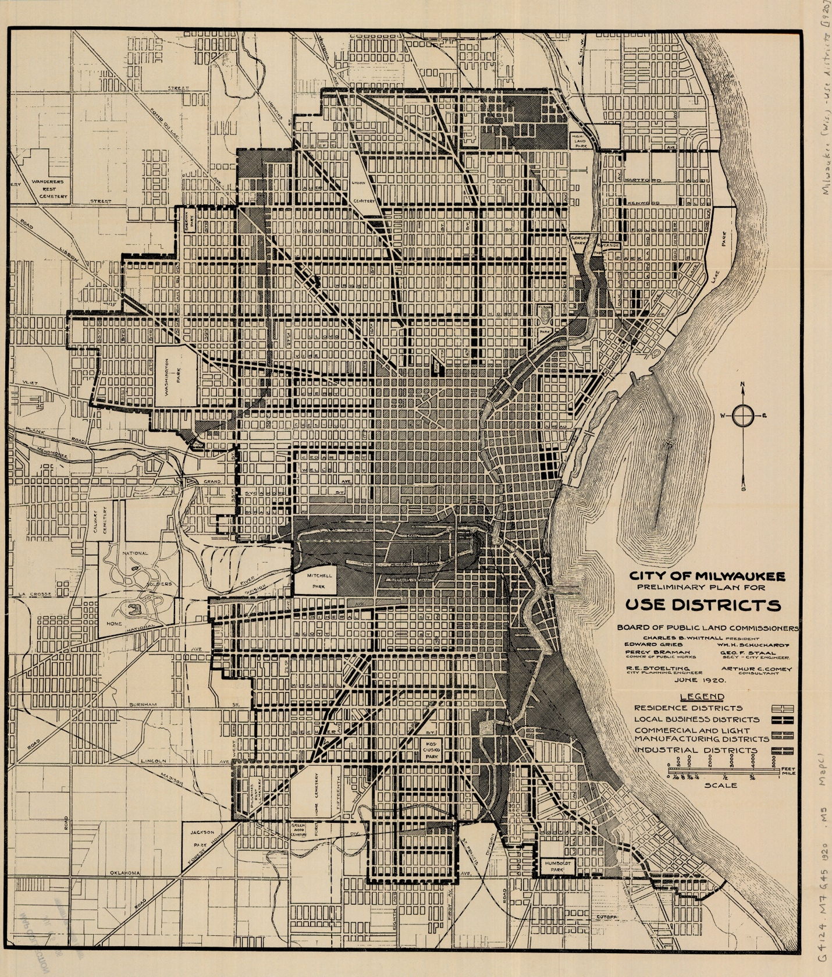
Figure 2: Map showing economic zoning in Milwaukee from the 1920 ordinance.
Racially restrictive covenants and economic zoning hindered Black Milwaukeeans’ aspirations for residential improvement during the prosperous Roaring Twenties. Economic growth continued until the 1929 stock market crash and unhelpful government policies plunged the United States into the Great Depression. Democratic Governor of New York Franklin Delano Roosevelt was elected president by a landslide in 1932, promising unprecedented federal government reform and expansion to quicken economic recovery in his platform titled the “New Deal.” The 1930s, however, witnessed deepening racial segregation due to New Deal banking and housing policies. The optimistic promises of Roosevelt’s recovery programs uplifted white people while marginalizing African Americans.
Starting in 1933, the federal Home Owners’ Loan Corporation (HOLC) discriminated on the basis of race to whom they loaned, deeming urban areas populated by Black people as untrustworthy to repay debt. These neighborhoods were marked in red to signify their perceived high credit risk. Thus, the discriminatory financial practice called redlining began. Meanwhile, white residential neighborhoods were marked by federal maps as the worthiest of receiving loans. Consequently, white neighborhoods received aid for recovering from the Depression while Black districts remained in economic downturn. Without external investment, African Americans in redlined neighborhoods could not afford maintenance for their property, which were showing drastic signs of aging. Because of restrictions on where Black people could live, landlords in the Black district often exploited the situation by overcharging and neglecting upkeep. As the 1930s continued, Black-owned homes and businesses deteriorated, leading to the creation of slums or “urban blight.”
The 1938 map for the HOLC illustrates redlining in Milwaukee (See figure 3, page 13). Restrictive covenants had limited Black Milwaukeeans to the Third and Sixth Wards of the city center. Economic zoning had made the Black district less desirable for living with commercial, manufacturing, and vice activities being permitted. With the arrival of the Great Depression, the Third and Sixth Wards were designated as “fourth grade” and marked in red. The HOLC and other lending institutions refused to invest in those wards, preventing economic recovery. Meanwhile, all-white neighborhoods like Shorewood and Whitefish Bay along the northeastern lakeshore were labeled “first grade” and “second grade.” Banks prioritized these areas in recovery policy by readily loaning to them. Consequently, redlined Black neighborhoods suffered the most in the Depression while areas populated by wealthier white people recovered the quickest.
Unsurprisingly, the Depression was hardest for working-class people. In periods of layoffs, companies often fired Black workers first. Likewise, white households laid off Black domestic servants to minimize expenses. By the 1930s, though, many African-American workers who were former migrants had joined unions. The American Federation of Labor (AFL), the largest union in the United States, had segregated subdivisions for Black workers. In AFL locals, however, Black members had limited say within the organization. In addition, white unionists continued feeling animosity toward Black workers for being used as strikebreakers.
In Milwaukee, labor action again precipitated into racial conflict. In 1934, white factory workers who were AFL members staged a walkout at the Wehr Steel Foundry. The white workers bargained for the “dismissal of Negroes from the plant.” The Wehr Steel Foundry and other companies had pacts with Black workers expecting intense loyalty in return for employment. When the company exploited racial friction to dismantle union power, white workers striked so companies would fire African Americans from industrial roles. When police arrived at the scene, they joined the white picketers and attacked Black strikebreakers who continued working as they protested. Disillusioned by the Wehr incident, Black workers felt estranged from the AFL. They later found institutional support for labor and civil rights from the Wisconsin branch of the Congress of Industrial Organizations (CIO), a rival union of the AFL.
New Deal institutions had to implement racial segregation to receive Southern support,
even in places outside the South. In practice, this involved the federal government requiring federally funded housing projects to match the racial composition of areas in which they were built. The federal government continued this segregationist policy with the United States Housing Act of 1937, also known as the Wagner-Steagall Act. The act allowed the federal government to fund municipal governments to construct public housing, with the precondition
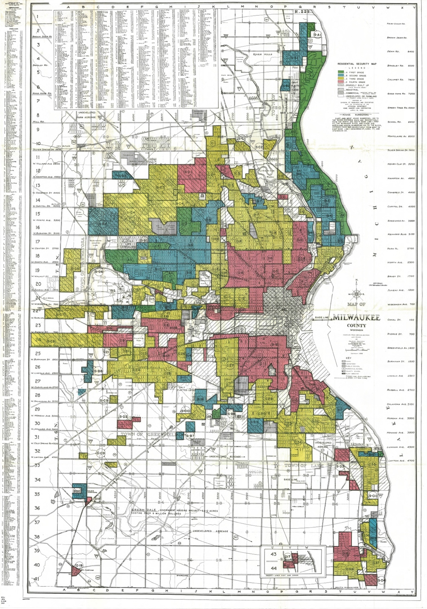
Figure 3: 1938 Home Owners’ Loan Corporation (HOLC) map showing redlining in Milwaukee.

that city governments establish local housing authorities. Milwaukee had not created its own housing authority, but the city still built locally funded public housing. Mirroring federal policy, the projects built in Milwaukee forbade Black tenants in projects built in white areas.

Race and Wartime Urban Policies, 1940–1944
In Milwaukee and the Midwest, racialized local and federal policies crystallized into Northern Jim Crow. The Wisconsin Enterprise-Blade, a statewide Black newspaper in Wisconsin headed by James W. Dorsey, critiqued federal policies implementing segregation in the state: “For the Negro, the New Deal has been the Old Deal in new clothes.” Likening the Democratic Executive Administration to Hitler, Stalin, and Mussolini, Dorsey professed that “it has helped spread jim crowism over the country where it had not before existed.” Indeed, governments at all levels enforced racial segregation in Northern cities.
In the urban Midwest, African Americans seeking better homes experienced backlash from white neighborhoods. In Cleveland and Chicago, the location of public housing projects for Black people near white communities was the object of white residents’ hostility. In Milwaukee, white resistance to Black people moving into all-white neighborhoods was reinforced in 1942. On May 5, the Wisconsin Supreme Court upheld racial covenants in Doherty v. Rice. In the small southern Wisconsin Town of Delavan, homeowner W.G. Doherty sold Jas W. Rice and his wife a lakefront property in 1940. The property had a covenant that “restricted against sale to or occupation by any one not a member of the Caucasian race.” The Rice family was Black. It is unclear whether Doherty knew he was selling to Black people in violation of the restrictive covenant on his property. He sued anyway to repossess the plot. The State Supreme Court ruled that the previous owner could request the removal of the current owner since the Rice family violated the restrictive covenant for being nonwhite. White segregationists in Wisconsin now had undisputed power to racialize residential space in rural communities like Delavan or urban metropolises like Milwaukee.
Court decisions like Doherty v. Rice encoded racial segregation into the laws of Northern states As more Black people migrated to urban centers, the already small turf untouched by restrictive covenants became overcrowded. In addition, policies like economic zoning and redlining caused property and standards of living in those areas to deteriorate. The compilation of all these conditions made Northern cities tinderboxes for racial unrest.
In the summer of 1943, many cities exploded into bouts of racial violence. Detroit, the industrial “Arsenal of America,” experienced a bloody race riot that made nationwide headlines. After 1942, Detroit defense industries’ employment of Southern Black migrants numbered over 35,000. There was a racially charged atmosphere from competition over labor and housing. Black newcomers fought with Polish Detroiters for residences in the federally subsidized Sojourner Truth Homes housing project. An individual brawl escalated into full-blown rioting from June 20 to 23. The disturbance ended when Michigan State Troopers and the Ninth Infantry division arrived after authorization by President Roosevelt. The riot resulted in twenty-five Black deaths, nine white deaths, seven-hundred-and-sixty-five injuries, and an estimated two million dollars in property damage. The Detroit Police Department disproportionately arrested Black men involved in the riot. In addition, they killed seventeen Black men by using deadly force. Law enforcement caused none of the white riot deaths, showing their blatant racial discrimination.
In 1943, Detroit was not the only American city to experience racial unrest. Riots also occurred in large urban centers like Los Angeles and New York as well as Southern communities like Mobile and Beaumont. Watching the epidemic of racial violence, Milwaukee organizations and urban planners discussed the possibility of similar riots happening in the city. Seeing the dismal condition of Black inner-core wards as a potential catalyst for rioting in Milwaukee, the racially integrated Congress of Industrial Organizations (CIO) appealed to the acting mayor of the city.

Detroit’s Shadow Casts onto Milwaukee
On 11 December 1943, Acting Mayor John L. Bohn received a letter from Milwaukee County CIO Secretary-Treasurer Mel J. Heinritz encouraging the appointment of a committee on race relations. The union leader addressed that “Although Milwaukee has no recent history of sharp relations between Negro and white, the interests of the war effort demand that we consider the serious grievances that do exist in the 6th ward.” Giving attention to nationwide unrest, Heinritz said that it was “also possible that pro-Nazi and 5th column elements that exist in the city may attempt to arouse prejudices to do such damage as has been done in Detroit, Mobile, Los Angeles, etc.” To confront these matters, the CIO recommended Mayor Bohn to create an “Advisory Committee on Inter-Racial Relations.” The union leader suggested that the mayor call a “conference of labor, civic, church, and fraternal organizations to discuss inter-racial problems in the city.” The proposed committee would also host “educational campaigns against discrimination in every walk of life.”
The CIO identified three places where the inter-racial relations committee should address discrimination against African Americans: employment, housing, and policing. Despite some progress being made in integrating defense industries after the establishment of the Fair Employment Practice Committee by President Roosevelt in 1941, Black people in Milwaukee continued to struggle with employment in industries because discrimination was difficult to prove. To advance Black people’s access to industrial jobs, Heinritz recommended that city government and public facilities model racial integration: “It is difficult to expect these barriers in private industry to be overcome, as long as similar barriers exist in the occupations of a public character and therefore presumably give public sanction to discriminatory practices.” Disappointed, Heinritz compared Milwaukee to Chicago where Black people can work in public roles like transportation while Milwaukee public high schools had no Black teachers. Framing public services in Milwaukee as behind its Midwestern neighbors, the CIO urged the mayor to catch up in racial integration with a Committee on Inter-Racial Relations.
In addition to employment, the CIO also demanded that Black people receive better housing conditions and treatment from police. Reminding the threat of Detroit-like riots in Milwaukee, Heinritz warned that white resistance “to any plan for advancing housing for
Negroes, is fraught with danger to the city” by preventing “the integration of Negroes and whites into a harmonious community.” Comparing law enforcement with the United States’ racist enemy in World War II, Heinritz likened racial discrimination in policing as hindering the American war effort against Nazi Germany. Heinritz recommended that “with the record of the police activities in the Detroit situation in mind, it would be well to check closely into the question of the police force, as it is known that in the past there have been elements friendly to the Nazis on the force.” Here, the CIO also reminded Mayor Bohn that police officers targeted Black people with arrests and lethal force in the Detroit riots.
To progress the improvement of race relations, Heinritz argued that the city must unify all Milwaukeeans under the shared goal of supporting the war effort. As in Detroit, racial disturbances in Midwestern defense industry hubs disrupted American weapons production for fighting in Europe and the Pacific. Heinritz emphasized that the white people in Milwaukee “must begin solving the serious grievances of the Negro people so that they may be in a better position to increase their already valuable contributions to the war effort.” To improve Home Front productivity through addressing racial inequalities, the CIO proposed the Mayoral Committee on Inter-Racial Relations: “through educational work among the white people as
to the character of this war for the preservation of our country and our democratic ideals, we will guard against such disruption of the country’s war effort as took place in Detroit.”
Resulting from his correspondence with the CIO, Mayor Bohn sent out letters to prominent law firms, industries, social agencies, schools, religious organizations, and unions in Milwaukee on 28 December 1943. The letter stated his intent to form the Mayoral Committee on Inter-Racial Relations as advised by the CIO. Bohn inquired lists of potential committee members from the influential and predominately white cohort. In their responses, the community members had mixed opinions in their responses to the query. Many agreed that there was a housing problem in the Third and Sixth Wards “where the living conditions are deplorable.” On the other hand, some believed that creating the Committee on Inter-Racial Relations would only heighten racial disputes or look for problems where there are none.
On 28 June 1944, Mayor Bohn announced the creation of the Mayoral Committee on Inter-Racial Relations to the Common Council. The Committee, however, appeared weak in its efforts against racial discrimination. First, the mayor only invited two Black people to be part of the Committee on Inter-Racial Relations: Young Women’s Christian Organization (YWCA) secretary Bernice Copeland-Lindsay and attorney George R. Brawley. With limited representation, African Americans in Milwaukee had less influence to move forward policies improving employment, housing, and police misconduct. Second, the Committee’s employment resolution petitioning businesses to practice “employment practices of nondiscrimination for racial or creedal differences” had no guidelines for enforcement. In addition, the Committee organized educational meetings at public schools for the public, again without any legal challenges. Without any strong policies, the Committee on Inter-Racial Relations seemed to have little power in combatting discriminatory opinions and practices among white Milwaukeeans.

Abe’s Resolution
While the city government floundered to create municipal remedies for the poor conditions in the Black district, well-off Black families purchased land in the all-white Carlton’s Addition located in Milwaukee’s outskirts. On 31 July 1944, city alderman August J. Abe maneuvered a resolution to halt African-American buyers and preserve the neighborhood’s all-white status. With the power of eminent domain, the suburban Black property owners would be forced to relinquish their land for compensation. From the aid of one alderman, the white neighbors had succeeded in putting their desire for racial segregation into Milwaukee law.
When word spread that the Common Council passed Abe’s Resolution, protest ensued. To share concerns about the Resolution, one-hundred-and-fifty people gathered at the Association Hall. Protesting city hypocrisy in housing policy, Black lawyer and race relations committee member George R. Brawley questioned that “If the city cannot enter public housing in the sixth ward to provide Negroes with decent homes, why does the council suddenly decide to develop a project out here where Negroes have bought property?” Other prominent Black lawyers in Wisconsin joined Brawley. George W. Hamilton asserted that “We [Black people] are not asking for privileges but demanding inalienable rights.” Adalbert Hurtt, one of the Black property owners in the contested area, added his experience of white neighbors trying to intimidate him so he would move away. In response to Hurtt’s testimony, James W. Dorsey trumpeted that “We have our Bilbos of Mississippi, our Connallys of Texas, right here in Milwaukee. There is still a remnant of the philosophy that we are slaves.” Abe’s Resolution put Milwaukee’s segregated housing and racialized urbanism centerstage in 1944.
The Common Council could not ignore complaints about the obviously segregationist legislation. The Council scheduled for Abe’s Resolution to be litigated on October 9. Racial tensions were already high when the time for the proceeding came around. Attempting to diffuse racial overtones and maintain the illusion that Milwaukee law was colorblind, Alderman E. A. Hansen warned that “arguments on ‘racial or religious issues’ would not be tolerated.” However, when not discussing race became impossible because of the racialized nature of the Resolution, Hansen “relaxed the original rules.” Despite race becoming open for conversation, participants in the parley continued to maintain attitudes of colorblindness. Milwaukee Housing Authority Member Rev. Cecil A. Fisher rebuked Roy Scherbarth, one of the white neighbors in favor of the Resolution, when Scherbarth said he was “speaking for the white side.” Fisher rejected this rhetoric of sides, asking him “Why a ‘white side’; I speak as an American.” The belief that Milwaukee society and law was colorblind and exceptional when compared to Southern Jim Crow was challenged in the discussions about Abe’s Resolution. Unpacking this moment as a history not just of segregation in Milwaukee, but of how segregation was and has continued to be perceived, and erased, tells us something important about the narratives around race that continue to shape contemporary Milwaukee.
After the proceeding, the Common Council unanimously discarded the Resolution on October 30. Despite the defeat of his measure repurposing the Black-owned properties into a playground, Alderman Abe immediately passed another resolution restricting landowners in the area, this time with the majority support of the Common Council. Despite perceived victories, government-sanctioned racism continued to influence racialized urbanism in Milwaukee.

Segregation, Unrest, and Open Housing, 1944–1968
The combination of segregated public housing, restrictive covenants, denied G.I. Bill subsidies, blockbusting, and anti-Black hostility cemented segregation in Milwaukee. In a 1965 report, Milwaukee had the lowest rate of suburbanized African Americans in the country. Concentrating Black people in inner-core neighborhoods, the city had constructed an intense color line resisting dismantlement. The litigation of Abe’s Resolution, confirmation of restrictive covenants in Doherty v. Rice, and weakness of the Committee on Inter-Racial Relations in wartime Milwaukee showed that the city was not exceptional to nationwide trends of racialized urban policy, municipal inaction, and Northern Jim Crow.
In the decades following World War II, residential segregation in Milwaukee will only intensify. White suburbanization and increased Black migration greatly contributed to postwar segregation. New Deal programs like the Home Owners Loan Corporation, the Federal Housing Administration (FHA), and the Servicemen’s Readjustment Act of 1944 (G.I. Bill) allowed many middle-class and working-class white Americans to achieve homeownership for the first time. Through the G.I. Bill, the Department of Veteran’s Affairs (VA) issued mortgage subsidies. As a result, white families in Milwaukee could afford moving to affluent suburbs like Shorewood, Whitefish Bay, Wauwatosa, and Mequon. The VA, however, denied families of Black veterans the benefits from the G.I. Bill package. In consequence, wealth inequality between white and Black Americans widened. As white families moved to urban exteriors, Black urban areas became more concentrated in population until they expanded into previously white neighborhoods. In addition, urban public housing had become racialized and viewed as only for low-income Black families. As white and Black people increasingly lived around only others of the same race, segregation in postwar Northern cities became almost absolute.
Amid the postwar changes in urban geography, Black Americans achieved a landmark court victory in housing. In 1948, the United States Supreme Court ruled in Shelley v. Kraemer that state governments and courts could not enforce restrictive covenants due to the Equal Protection Clause of the Fourteenth Amendment. The case involved two cases in the Midwest from the Supreme Courts of Missouri and Michigan, respectively Shelley v. Kraemer and McGhee v. Sipes. The federal case overruled the Wisconsin legal precedent regarding restrictive covenants from Doherty v. Rice. Restrictive covenants no longer had the backing of Wisconsin courts. Despite being unenforceable after Shelley, racially restrictive covenants were still legal and reflected hostile attitudes among white homeowners toward having Black neighbors.
As more African Americans migrated to Milwaukee, their racialized concentration in the Inner Core increased. Likewise, low-rent housing projects became primarily located in pre-existing Black neighborhoods, reinforcing residential segregation. The Black district in Milwaukee began to resemble the “ghettoes” or “Black belts” of other Midwestern cities like Chicago and Detroit. A 1968 map (See figure 4, page 29) visualizes the concentration of Black residents and low-income housing projects in the Inner Core. The dots on the map show constructed and proposed housing developments. Most of them are located within the segregated Black community shown as a layered oval. The map labels the inner ring of the oval as “Predominately Black Areas” and outer ring as “Racially Mixed or Changing Areas.” The distinction between the two levels of racial concentration shows the occurrence of white flight and blockbusting. White residents moved to suburban neighborhoods to escape living around Black people and out of fear of declining property values. Through practices known as blockbusting, real estate agencies took advantage of white fear to rapidly buy white homes at lowered rates and then sell to Black families at higher rates. Despite the ruling in Shelley that restrictive covenants could not be enforced in court, informal agreements between white neighbors not to sell to Black home seekers prevented African-American movement to places outside the Inner Core.
Some activists, though, fought against housing restrictions. In 1960, Wisconsin NAACP leader Lloyd Barbee and Attorney Tom Jacobson led a fourteen-day sit-in to promote their open housing bill for the state legislature in Madison. Vel Phillips, the first and sole Black alderwoman of Milwaukee at the time, repeatedly proposed open housing ordinances to the Common Council. Every time she presented a bill, however, all eighteen other aldermen would vote against it. Open housing became the primary goal of advocates for change in Milwaukee.
At the federal level, President Lyndon Baines Johnson wanted to include a federal open housing section to the 1966 Civil Rights Act. However, legislators supported by real estate lobbyists prevented the measure from being passed. In response to the federal failure of enforcing open housing, local communities in the urban North staged intense civil rights campaigns.
Viewing themselves as part of the nationwide Civil Rights Movement, groups like the Milwaukee United School Integration Committee (MUSIC) and Milwaukee NAACP Youth Council (YC) had organized to fight against racial inequality in Milwaukee. Led by NAACP leader Lloyd Barbee, MUSIC arranged public school boycotts against segregation. They targeted segregated policies like intact busing, Milwaukee Public Schools’ effort to alleviate overcrowding in inner-core schools by busing students to public schools in predominately white schools. Throughout the school day, bused Blacks students were entirely separated from white classrooms and students. MUSIC challenged the practice until activities of the organization waned in 1966.
The YC focused on advocating for Black people to live anywhere in Milwaukee, known to them as open housing. Under the unique direction of white Catholic priest James Groppi, the group orchestrated marches and picketing in white suburbs where Black people could not live due to discrimination. In a locally famous instance, the group peacefully marched across the Sixteenth Street viaduct from the Black Inner Core to the covenant-riddled white and Polish South Milwaukee. In another instance in the suburb of Wauwatosa on 21 August 1966, they picketed in front of the house of a judge who was member of a racially exclusive fraternal organization that influenced local political decisions. In all protests, the YC experienced fierce white resistance when they challenged the racial segregation and discrimination evident in the allocation of and access to civic space in the city. During the peaceful march into South Milwaukee, white onlookers and residents shouted racist chants and threw objects like bottles, rocks, and firecrackers. During the protests in Wauwatosa, picketers even witnessed robed Klansmen intervene, attempting to intimidate the YC into leaving the all-white suburb.
In this phase of the national Civil Rights Movement, relations between Black residents and law enforcement deteriorated. In summer 1967, racial unrest had taken place in Detroit, Newark, and other cities across the United States. On July 30, rioting also broke out in Milwaukee. According to historian Patrick Jones, episodes like the one in Milwaukee often “mark the first entrance of the urban North into the postwar civil rights narrative and are usually explained as part of a broader wrong turn for the Movement during the Black Power era, away from the nonviolent, interracial, and reform-minded activism of the first half of the 1960s and toward violence, racial exclusivity, and revolution in the late 1960s and early 1970s.” He argued that these narratives are problematic because they do not consider factors preceding the unrest like Northern civil rights activism, rapid urban decline, worsening police-community relations, government inaction, and rationale for anger amid severe poverty and discrimination.
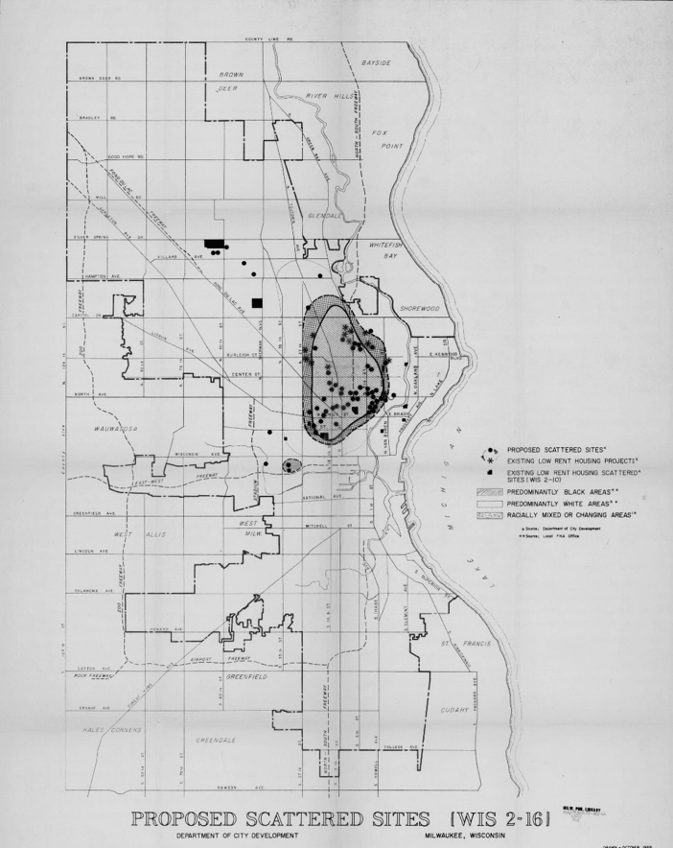
Figure 4: Map showing the racial geography of Milwaukee in 1968. The asterisks, dots, and blocks signify constructed or proposed low-rent housing sites.
By 1968, the movement for open housing in Milwaukee lost steam. Its last demonstration happened on March 21. Not long after, Martin Luther King, Jr. was assassinated in Memphis on April 4. The remorse and anger that followed prompted President Johnson to sign the Fair Housing Act of 1968 into law, outlawing discriminatory practices like restrictive covenants, redlining, and blockbusting.

Conclusion
Segregation past the Fair Housing Act of 1968 illustrates the continuity of racialized urbanism. Despite the illegality of discrimination in homeownership, Milwaukee remains to be one of the most segregated cities in the United States into the 21st century. An entire gamut of inter-racial relations committees, rescissions of discriminatory laws, Shelley, and the Fair Housing Act have been inadequate to dismantling residential segregation in Milwaukee. In response to the question How did Milwaukee become so segregated?, racialized and discriminatory residential practices in public and private spheres before, during, and after World War II fortified a durable structure of racial separation and inequality. The compounding of racist urban development policies like economic zoning, restrictive covenants, redlining, discrimination in labor, exclusion from government benefits, segregated public housing, blockbusting, and policing has systemically hindered Black Americans from building generational wealth, community, and ontological security. In the wartime moment of 1940–1944, nationwide rioting and local racialized law brought segregation and inequality to the forefront in Milwaukee. This moment was important because it modeled the open housing movement, racial violence, and insufficient government action of Milwaukee’s following decades. New solutions for racial segregation and inequality, however, must differ from previous efforts to have a greater impact.

Bibliography

Primary Sources:

Newspapers:

The Milwaukee Journal.

The Wisconsin Enterprise-Blade.

CIO News.

Archival:

John L. Bohn Mayoral Records. Milwaukee Public Library.

Irene Bishop Collection Goggans. Milwaukee Public Library.

Cecil A. Fisher Files. University of Wisconsin-Milwaukee.

United Way Files. University of Wisconsin-Milwaukee.

Maps:

Board of Public Land Commissioners, City of Milwaukee, preliminary plan for use districts (map), June 1920, The University of Chicago Map Collection, University of Chicago.

Department of City Development. Proposed scattered sites (map), 1968, Humanities Map Collection, Milwaukee Public Library.

Esri Demographics Team. Race and Ethnicity in the US by Dot Density (2020 Census). https://www.arcgis.com/home/item.html?id=30d2e10d4d694b3eb4dc4d2e58dbb5a5.

Federal Home Loan Bank Board. Map of Milwaukee County, Wisconsin: Residential Security Map (map), 1938, American Geographical Society Library Digital Map Collection, University of Wisconsin-Milwaukee.

Legal:

Doherty v. Rice, 240 Wis. 389 (May 5, 1942).

Resolution by August J. Abe. File no. 79853. Milwaukee Common Council, July 31, 1944. Milwaukee Municipal Research Library.

Shelley v. Kraemer, 334 U.S. 1 (1948).

Secondary Sources:

Biles, Roger. “Race and Housing in Chicago.” Journal of the Illinois State Historical Society 94, no. 1 (2001): 31–38.

Bonds, Michael. Early Black Milwaukee (1830 to 1920): The Origins of an Urban Minority. Amazon Publishing Central, 2023.

Capeci, Dominic J. and Martha Wilkerson. Layered Violence: The Detroit Rioters of 1943. University Press of Mississippi, 1991.

Dougherty, Jack. More Than One Struggle: The Evolution of Black School Reform in Milwaukee. The University of North Carolina Press, 2004.

Fure-Slocum, Eric. Contesting the Postwar City: Working-Class and Growth Politics in 1940s Milwaukee. Cambridge University Press, 2013.

Gurda, John. The Making of Milwaukee. 3rd ed. Milwaukee County Historical Society, 2006.

Imse, Thomas. “The Negro Community in Milwaukee.” MA thesis. Marquette University, 1942.

Jenkins, Destin. The Bonds of Inequality: Debt and the Making of the American City. The University of Chicago Press, 2021.

Jones, Patrick. The Selma of the North. Harvard University Press, 2010.

Jones, Sandra E. Voices of Milwaukee Bronzeville. The History Press, 2021.

Krumbiegel, E. R. “Observations on Housing Conditions in Milwaukee’s Sixth Ward: A Report to the Honorable John L. Bohn, Mayor, and the Members of the Common Council of the City of Milwaukee.” 1944.

Lenard, Vivian. “From Progressivism to Procrastination: The Fight for the Creation of a Permanent Housing Authority, 1933-1945.” MA thesis. University of Wisconsin-Milwaukee, 1967.

Lynaugh, Paula. “Milwaukee’s Negro Community.” Citizens' Governmental Research Bureau of Milwaukee, 1946.
Márquez, Cecilia. Making the Latino South: A History of Racial Formation. The University of North Carolina Press, 2023.

Michney, Todd M. “Constrained Communities: Black Cleveland's Experience with World War II Public Housing.” Journal of Social History 40, no. 4 (2007): 933–56.

Muhammad, Khalil Gibran. The Condemnation of Blackness: Race, Crime, and the Making of Modern Urban America. Harvard University Press, 2011.

Purnell, Brian and Jeanne Theoharis. “Introduction: Histories of Racism and Resistance, Seen and Unseen: How and Why to Think about the Jim Crow North.” In Strange Careers of the Jim Crow North, edited by Brian Purnell and Jeanne Theoharis, with Komozi Woodard, 1–42. New York University Press, 2019.

Quinn, Lois M. “Racially Restrictive Covenants: The Making of All-White Suburbs in Milwaukee County.” Milwaukee Integration Research Center, 1979.

Rothstein, Richard. The Color of Law: A Forgotten History of How Our Government Segregated America. Liveright Publishing Corporation, 2017.

Takei, Hiroshi. “The Unexpected Consequence of Government Manipulation: Racial Disturbances at Chicago’s Public Housing for Veterans in the 1940s.” Institute of American and Canadian Studies Journal 31, no. 1 (2013): 49–77.

Trotter, Joe William, Jr. Black Milwaukee: The Making of an Industrial Proletariat, 1915–45. University of Illinois Press, 1985.

———. “The Historiography of Black Workers in the Urban Midwest: Toward a Regional Synthesis.” Studies in Midwestern History 4, no. 4 (2018): 1–22.

———. Black Milwaukee: The Making of an Industrial Proletariat, 1915–45. 2nd ed. University of Illinois Press, 2007.

Voogd, Jan. Race Riots and Resistance: The Red Summer of 1919. Peter Lang Publishing, 2008.

“Playground Parley Is Stormy One: Opposed Playground Plan in Areas in Which Negroes Have Bought Lots,” Milwaukee Journal, October 10, 1944.
Resolution by August J. Abe, file no. 79853, Milwaukee Common Council, July 31, 1944.
“Playground Parley Is Stormy One.”
“Playground Parley Is Stormy One.”
“Playground Parley Is Stormy One.”
“Playground Parley Is Stormy One.”
“Playground Parley Is Stormy One.”
Patrick Jones, The Selma of the North: Civil Rights Insurgency in Milwaukee (Harvard University Press, 2010), 4–6.
Esri Demographics Team, “Race and Ethnicity in the US by Dot Density (2020 Census).”
For example, Black Lives Matter (BLM). See Brian Purnell and Jeanne Theoharis, “Introduction: Histories of Racism and Resistance, Seen and Unseen: How and Why to Think about the Jim Crow North,” in Strange Careers of the Jim Crow North, edited by Brian Purnell and Jeanne Theoharis, with Komozi Woodard (New York University Press, 2019), 31–32.
Roger Biles, “Race and Housing in Chicago,” Journal of the Illinois State Historical Society 94, no. 1 (2001): 32.
John Gurda, The Making of Milwaukee, 3rd ed. (Milwaukee County Historical Society, 2006), 175; Jones, Selma of the North, 17; Imse, 8.
Sandra E. Jones, Voices of Milwaukee Bronzeville (The History Press, 2021), 33.
Jan Voogd, Race Riots and Resistance: The Red Summer of 1919 (Peter Lang Publishing, 2008), 41.
The term “race riot” has changed meaning through the 20th and 21st centuries. Initially, race riots signified white mob violence from 1919–1923 and briefly in 1943. From 1960s onward, however, the term became associated with Black protesters destroying their own neighborhoods. Voogd posits that “Such a polar transformation in meaning can generate confusion and erroneous assumptions, particularly in hiding white responsibility for violence.” Voogd, 2.
Voogd, 44.
Trotter, Black Milwaukee, 39, 54–55.
Jones, Selma of the North, 9–11.
Rothstein, 43–48.
Rothstein, 48.
Rothstein, 49.
Board of Public Land Commissioners, City of Milwaukee, preliminary plan for use districts (map), June 1920, The University of Chicago Map Collection, University of Chicago.
Fure-Slocum, 69.
Rothstein, 268.
In addition to Black people, restrictive covenants often excluded Jewish and Asian people from owning and occupying homes in white neighborhoods. Most covenants permitted people of color to work as servants in restricted homes during daytime hours: “this is not intended to include or prevent occupancy by such person as a domestic servant or while actually employed in or about the premises by the owner or occupant thereof.” Lois M. Quinn, “Racially Restrictive Covenants: The Making of All-White Suburbs in Milwaukee County,” Milwaukee Integration Research Center (1979), 14.
“Inner Core” is the local term in Milwaukee for the Black “inner city” or “ghetto.” Jones, Selma of the North, 19.
Board of Public Land Commissioners, City of Milwaukee, preliminary plan for use districts (map).
Destin Jenkins, The Bonds of Inequality: Debt and the Making of the American City (The University of Chicago Press, 2021), 22.
Imse, 12.
Imse, 13.
Board of Public Land Commissioners, City of Milwaukee, preliminary plan for use districts (map), June 1920, The University of Chicago Map Collection, University of Chicago; Rothstein, 50.
Federal Home Loan Bank Board, Map of Milwaukee County, Wisconsin: Residential Security Map (map), 1938, American Geographical Society Library Digital Map Collection, University of Wisconsin-Milwaukee.
Federal Home Loan Bank Board, Map of Milwaukee County, Wisconsin: Residential Security Map (map).
Imse, 4.
Imse, 4.
Trotter, Black Milwaukee, 63.
William V. Kelley to T. Arnold Hill, 21 Sept. 1934, ser. 4, box 8, NUL Papers. Quoted in Trotter, Black Milwaukee, 154–156.
Trotter, Black Milwaukee, 152–154.
Trotter, Black Milwaukee, 156.
Trotter, Black Milwaukee, 188; Eric Fure-Slocum, Contesting the Postwar City: Working-Class and Growth Politics in 1940s Milwaukee (Cambridge University Press, 2013), 61–63.
Rothstein, 4.
Rothstein, 21.
Federal Home Loan Bank Board, Map of Milwaukee County, Wisconsin: Residential Security Map (map).
Vivian Lenard, “From Progressivism to Procrastination: The Fight for the Creation of a Permanent Housing Authority, 1933-1945” (MA thesis, University of Wisconsin-Milwaukee, 1967), 24–29; Hiroshi Takei, “The Unexpected Consequence of Government Manipulation: Racial Disturbances at Chicago’s Public Housing for Veterans in the 1940s,” Institute of American and Canadian Studies Journal 31, no. 1 (2013): 50, 53–54; Rothstein, 23.
Bondholders who had invested in housing projects also influenced their policies on segregation. Because cities were indebted to wealthy individuals for their investments in public projects, those predominately white bondholders shaped their policies regarding race. For the role of municipal bonds in racialized urban development, see Jenkins, Bonds of Inequality.
“Milwaukee Slant on F.H.A. Discrimination,” Wisconsin Enterprise-Blade, September 28, 1940.
For white resistance to Black public housing in Cleveland, see Michney, “Constrained Communities: Black Cleveland's Experience with World War II Public Housing.” For Chicago, see Takei, “The Unexpected Consequence of Government Manipulation.”
Doherty v. Rice, 240 Wis. 389 (May 5, 1942). For other affirmations of restrictive covenants in state supreme court cases, see Rothstein, 81–82.
Rothstein, 81–82.
Dominic J. Capeci and Martha Wilkerson, Layered Violence: The Detroit Rioters of 1943 (University Press of Mississippi, 1991), 3.
Capeci and Wilkerson, 4.
Capeci and Wilkerson, 17.
Capeci and Wilkerson, 16–17.
Capeci and Wilkerson, 18.
Capeci and Wilkerson, 18–19
Mel J. Heinritz to John L. Bohn, 11 December 1943, Committee on Inter-racial Relations (1944) folder, box 8, John L. Bohn Mayoral Records, Milwaukee Public Library.
Heinritz to Bohn, December 11, 1943.
Heinritz to Bohn, December 11, 1943.
Imse, 42–43.
See Dougherty, More Than One Struggle, 27–31.
Heinritz to Bohn, December 11, 1943.
There were no copies of Bohn’s letter sent on December 28 in the John L. Bohn Mayoral Records. However, its contents can be inferred from correspondence surrounding it.
Hunter Tractor & Machinery Co. to John L. Bohn, 14 January 1944, Committee on Inter-racial Relations (1944) folder, box 8, John L. Bohn Mayoral Records, Milwaukee Public Library.
Evans and Eberbach to John L. Bohn, 14 January 1944, Committee on Inter-racial Relations (1944) folder, box 8, John L. Bohn Mayoral Records, Milwaukee Public Library.
John L. Bohn to the Common Council, 28 June 1944, Committee on Inter-racial Relations (1944) folder, box 8, John L. Bohn Mayoral Records, Milwaukee Public Library.
Employment Resolution, folder 11, box 15, John L. Bohn Mayoral Records, Milwaukee Public Library.
Institute on Race Relations: Sponsored by the Mayor’s Committee on Inter-Racial Relations with the Milwaukee Vocational School, 5 April 1945, folder 11, box 15, John L. Bohn Mayoral Records, Milwaukee Public Library.
“Plan for Play Area Assailed: Negro Group Resolution,” Milwaukee Journal, September 18, 1944.
“Plan for Play Area Assailed.”
“Plan for Play Area Assailed.”
“Plan for Play Area Assailed.”
“Plan for Play Area Assailed.”
“Plan for Play Area Assailed.”
“Plan for Play Area Assailed.”
“Plan for Play Area Assailed.”
“Plan for Play Area Assailed.”
Dan Lee, “The Color of Law in Milwaukee’s Carlton’s Addition,” 6 September 2018, folder 11, box 10, Irene Bishop Goggans Collection, Milwaukee Public Library, 3.
“City Job Setup Probe Is Voted,” Milwaukee Journal, November 14, 1944. See also Lee, 3.
Jones, Selma of the North, 173.
Jones, Selma of the North, 171.
Rothstein, 167.
Rothstein, 167.
Rothstein, 32–37.
Shelley v. Kraemer, 334 U.S. 1 (1948).
Department of City Development, Proposed scattered sites (map), 1968, Humanities Map Collection, Milwaukee Public Library.
Department of City Development, Proposed scattered sites (map).
Rothstein, 96–99.
Jones, Selma of the North, 174.
Jones, Selma of the North, 182–183.
Jones, Selma of the North, 172.
Dougherty, 104–105.
Dougherty, 94.
Dougherty, 104–105.
Jones, Selma of the North, 1.
Jones, Selma of the North, 111.
Jones, Selma of the North, 2.
Jones, Selma of the North, 109.
Jones, Selma of the North, 143.
Gurda, 376.
Jones, Selma of the North, 148.
Department of City Development, Proposed scattered sites (map).
Jones, Selma of the North, 208.

