Redefining Rosie: The Portrayal of American Women in World War II Mobilization Campaigns, 1941-1945

Katherine Drozd
HIS 480
Davidson College
December 9, 2025

Introduction
Over the course of World War II, nearly 19 million American women worked for wages. By 1944, “the female labor force had grown by almost half,” and women’s presence in traditionally male-dominated wartime occupations was unprecedented. The number of women employed as production workers skyrocketed “from 340,000 in 1940 to 2,174,000 in 1943,” and by 1945, “4.5 million women were serving as factory operatives, an increase of 112 percent.” These figures underscore the expanding role women played during the war, a shift actively promoted by a nationwide government campaign to recruit women into the workforce.
Embodied by Rosie the Riveter, government-sponsored propaganda encouraged women to go beyond the confines of domesticity and convinced them that they were needed, wanted, and important in the public sphere. Suddenly, middle-class women were not only mothers and homemakers, but also riveters and wielders. These recruitment campaigns seemed to project an image of female empowerment, patriotism, and strength, and, indeed, have since been remembered as such in popular culture. However, this public campaign and the new gender roles for middle-class women that it promoted were only temporary. Once the war ended, women rapidly exited the workforce just as quickly as they had entered it. Industrial needs shrank in the immediate postwar years, and riveters and welders were no longer needed to the extent that they were during the war years. The same government that had once recruited women into the workforce now encouraged them to return back to the home, causing “the female labor force [to shrink] to a size closer to that of 1940 than to that of 1944.”
Why did women enter the workforce so rapidly and then leave? Does this suggest that recruitment campaigns worked, or is there some other explanation for these shifts in middle-class women’s participation in wage labor? This paper reconsiders popular assumptions that these wartime mobilization efforts promoted female empowerment, arguing instead that these posters framed women in a way that encouraged them to enter the workforce while also perpetuating traditional domestic and feminine gender roles. Examining this contradiction, I argue, will help us better understand the process by which women entered and exited the workplace before and after World War II, illuminating how views of women’s domestic labor and the presence of visual regimes were reflected in wartime mobilization efforts aimed at women.
Although historians have examined how women were depicted in World War II recruitment campaigns, the scholarship remains overwhelmingly centered around Rosie the Riveter. Some scholars recount her origin story, while others dissect the construction of her cultural memory or use her as a gateway to broader discussions of wartime propaganda. This scholarly focus on a single figure has turned Rosie into what two historians call “a modern American legend,” effectively obscuring the fact that Rosie was only one among many images aimed at mobilizing women. By sidelining lesser-known posters, scholars have overlooked visual materials that reveal a more complex narrative: the effort to recruit women into wage labor while simultaneously reaffirming traditional gender expectations.
I argue that World War II recruitment propaganda presented female mobilization as a temporary expansion of women’s roles in the public sphere, one that ultimately left mid-20th century views of women within a patriarchal system—as mothers, housewives and caretakers—firmly intact. These posters, while calling on women to enter the wartime workforce, also reinforced the idea that their primary place remained in the private sphere by conditioning their participation in wage labor on their husband’s needs, approval, or absence. In doing so, female empowerment was gendered: women were encouraged to contribute to the war effort, but only in the ways that did not threaten patriarchal order—an effect that continued to be felt after the war through messaging that encouraged women to leave their wartime jobs and return home. Even though some women wanted to keep their wartime jobs, most understood that women’s place in the public sphere was temporary and returned home without a quarrel—almost as if their wartime efforts meant nothing.
By examining government recruitment posters and their depiction of gender, this paper argues that the historical shifts in women’s workforce entry and exit can in part be explained with reference to the paradoxical depiction of women’s place in the workforce in state-sponsored recruitment posters. I seek to address this by looking at how World War II recruitment propaganda mobilized American women while upholding the gender hierarchy and considering how the depiction of women reinforced traditional views of domesticity and femininity. I begin by situating my research within previous scholarship on World War II recruitment campaigns, highlighting how other scholars tend to overshadow lesser-known wartime posters that also shaped female mobilization. I then provide historical context on American society before World War II, outlining the prevailing expectation for women’s roles in the home and wage earning workforce. Next, I introduce my analytical framework, drawing on social reproduction theory and discussions of visual regimes, and apply it to examine how recruitment posters depicted women’s wage labor and framed female participation in the public sphere. Following this, I evaluate the effectiveness of these campaigns in mobilizing women while simultaneously reinforcing the traditional gender hierarchy. Finally, I turn to the immediate postwar period, showing how the gendered nature of wartime propaganda continued to shape women’s place in the public sphere and reinforced conventional notions of domesticity. By tracing this trajectory, this paper demonstrates that even the most iconic images of female empowerment ultimately functioned to uphold mid-20th century ideals of femininity and domestic labor.
Working Women?: The Historical Problem
Historians have studied World War II recruitment campaigns and the ways in which they both expanded and constrained women’s roles in the public sphere. They acknowledge that this period has been falsely remembered as a time of female empowerment, when in reality, traditional notions about women remained relatively unchanged. More importantly, leading scholars underscore that recruitment propaganda reinforced traditional views of women, such as femininity, sexuality, and domesticity, all the while seemingly advocating for female participation in the public sphere. However, my research differs from previous scholarship in two major ways. Firstly, while some scholars draw on privately produced posters, cartoons, and advertisements that mobilize women to support the military or homefront, I draw exclusively on state-sponsored posters aimed at increasing the number of women in the non-military workforce, such as industrial and factory work. Secondly, and more significantly, my framework sets me apart from previous scholarship. I draw on social reproduction theory and discussions of visual regimes to reveal the ways in which women were depicted as wage laborers without threatening patriarchal structures and how traditional notions of femininity were simultaneously preserved even as women participated in industrial work.
The American Woman: History of Gender and Women’s Roles
Gender history focuses on the relationship between sexes, insisting that men and women must be studied together to fully understand the power structures and societal expectations that shape both groups’ roles. Viewing gender as a critical category of analysis reveals how society constructs and enforces relationships of power and difference, relying on masculinity and femininity. As historian Joan Scott explains in her classic essay “Gender: A Useful Category of Analysis,” “gender is a primary way of signifying relationships of power.” Gender functions as a tool of dominance by those socialized as men over women; contrary to popular beliefs, these patterns are not the inevitable result of history, but rather are deliberately constructed and maintained through social, political, and economic systems. Gender history, therefore, forcefully challenges traditional narratives by exposing and dismantling the rigid gender roles present in society. Recognizing these links between gender and power, historians have clarified the definitions of masculinity and femininity. Masculinity has been associated with dominance, strength, and authority, while femininity has been cast as subversive, weak, and almost foreign. In this framework, women are positioned as a group to be controlled and dominated, highlighting the constructed gender hierarchy and reinforcing the perceived importance of “women’s maternal and reproductive functions.”
In this paper, I draw on Scott’s and other historians’ discussions to illustrate how World War II propaganda was gendered, centering the women it targeted in their maternal, domestic, and reproductive functions even as it encouraged them to adopt positions in the workforce alongside men. I use the word ‘gendered’ intentionally because it expresses how there were certain biases toward women, encompassing elements of inferiority and weakness, and these biases were present in these mobilization campaigns. Importantly, not only were they present in these mobilization campaigns, but they also played a crucial role in framing these campaigns in a way that was acceptable to American society —as I will discuss later on.
A World at War: The American Homefront During World War II
Leading up to World War II, the United States was still recovering from the Great Depression. Not only did the Great Depression devastate America’s economy, but it also harmed the country’s social progress, exemplified by the passage of the 19th Amendment in the 1920—granting women the right to vote. For the first time in American history, women were able to actively participate in politics. Once enfranchised, women desired to expand their political influence by championing issues, such as disarmament and the peace movement, and were successful. While only a select few were elected to the House of Representatives, more women were successful in gaining positions in local government, mainly because these positions were non-partisan and therefore aligned more with the belief that women should operate “above politics.”
Enfranchisement enabled women to expand beyond their domestic roles by participating in politics; however, this was short-lived as the economic realities of the depression set in. Women were called upon to comfort their families in this time of economic instability, revealing the ways in which domesticity could alleviate some of the economic burdens brought on by the Depression. Consequently, this promoted a view of womanhood that emphasized women’s role as head of the home—overshadowing the political momentum women gained in the 1920s.
Although the Great Depression emphasized women’s role as homemakers, it also required many to work outside the home, thereby expanding their roles as wage-earners. It was not uncommon for a married, single, or young woman to get a blue-collar, domestic, or service job out of economic need, particularly if they were part of the working-class. However, this did not mean that American society accepted working women. In fact, a majority of Americans took issue with wives working specifically—especially if their husbands had jobs—and even suggested that legislation be passed to prohibit wives from working. These negative attitudes toward working women reflected America’s reluctance to change gender roles, even in a time of crisis.
The United States officially entered World War II on December 8, 1941. After abandoning its isolationist policy and earlier efforts to maintain neutrality, the country needed to mobilize. America transformed its industrial sector to support the wartime demand. Hence, the demand for workers increased, leading to complex jobs being broken down into smaller tasks. These smaller, less complex jobs allowed workers to learn more quickly; however, men were called to serve in the military, forcing employers to find new workers. But who could possibly take on these jobs abandoned by men? The answer was simple: women could do it.
Beyond Rosie: Women in US-Sponsored World War II Recruitment Campaigns
Before examining some lesser-known war posters, this paper’s analytical framework can be illustrated through two of the most iconic examples: J. Howard Miller’s ‘We Can Do It!’ and Norman Rockwell’s ‘Rosie the Riveter.’ Applying social reproduction theory and discussions of visual regimes to these images reveal how wartime mobilization efforts aimed at women were not only structured around maintaining gendered divisions of labor but also presented women’s entry into industrial work as both a patriotic duty and an extension of their domestic responsibilities.
Social reproduction theory emphasizes that capitalism relies not only on waged labor but also on unwaged, invisible labor that reproduces the worker. Although social reproduction theory originated in an economic context, it offers a particularly valuable lens for examining invisible labor, such as feeding, caring for, and maintaining the social conditions necessary for production to continue. As an extension of Marxism—and more specifically, Marxist feminism—social reproduction theory holds that human labor is fundamental to the creation and reproduction of society. However, it argues that only market labor is traditionally recognized as “legitimate ‘work,’” thereby overlooking the essential labor involved in maintaining the market through ongoing production and maintenance of human life. Without this ongoing production of humans and the care for families in the domestic sphere through acts like cooking and cleaning, the production of goods would not be possible, underscoring the central role women play in supporting a capitalist society.
In this light, Miller’s ‘We Can Do It!’ (see figure 1), for example, can be seen as both celebrating and containing women’s labor. It publicly recognizes women as wage-earning workers, but only to the extent that their work sustains the system of production that capitalism depends on. Moreover, the framework of social reproduction theory highlights that women’s domestic work has been essential to the reproduction of labor power, yet Miller’s poster portrays women as ‘finally’ contributing to the economy by motivating women to get wartime jobs, effectively participating in visible labor. The poster’s call for women to join the wage-earning workforce suggests that laboring is a new endeavor for them, a notion that erases the essential, ongoing work women have always performed as wives, mothers, and caregivers. Thus, even as the poster seems to introduce a new kind of gender role, one where a woman is strong rather than subservient, Miller’s poster can be understood as a visual representation of how women’s unpaid domestic work is undervalued and unacknowledged.
Furthermore, this paper also relies on the presence of visual regimes as part of its analytical framework. In John Berger’s Ways of Seeing, he argues that visual perception is not neutral but rather influenced by a multitude of factors—including class, gender, culture, and history—and we can see how Norman Rockwell’s ‘Rosie the Riveter’ embodies a learned set of assumptions about gender (see figure 2). On the one hand, ‘Rosie the Riveter’ visually disrupts traditional expectations by placing a woman in a position of strength and action—muscular, self-assured, and fully engaged in industrial labor typically coded as masculine according to Berger. Her pose, with a riveting gun resting on her lap and foot pressing down on a copy of Mein Kampf, effectively redefines the portrayal of women by illustrating their power and patriotism rather than their beauty and contribution to the war effort through industrial labor. In this way, Rockwell’s poster appears to advance the idea of female empowerment by directly challenging traditional views of domesticity and femininity through Rosie’s rather masculine presence, as she appears covered in dirt and more muscular.
On the other hand, Rockwell’s poster simultaneously reinforces the very gendered visual regimes it seems to challenge. Her femininity remains unmistakably emphasized through her red lipstick, blushed cheeks, and pocket mirror poking out of her fitted jumpsuit, embodying some of the conventional beauty standards. Importantly, this emphasis on Rosie’s beauty exemplifies the presence of the male gaze, or, as Berger claims, the way “men look at women.” This fusion of strength and femininity reflects the balancing act at the heart of these mobilization efforts: women were encouraged to enter the workforce, but only temporarily and only to the extent that femininity is preserved. Moreover, Rockwell’s poster comments on women’s participation in the wartime wage earning workforce by casting the American flag as the backdrop. Through this use of a visual regime, Rockwell’s poster links women’s participation with patriotism, effectively demonstrating how this depiction was an extension of women’s patriotic duty. Therefore, Rockwell’s image mirrors the contradiction present in World War II recruitment campaigns aimed at women, which did not genuinely promote female empowerment by expanding women’s gender role as wage earners, but rather framed female mobilization to encourage workforce participation without threatening views of domesticity and femininity.
By integrating social reproduction theory with an analysis of the visual regimes embedded in US wartime recruitment posters, this paper argues that these images constructed a carefully managed vision of women’s empowerment: one that celebrated women’s entry into industrial labor while simultaneously containing it within longstanding gender norms. Through this framework, the paper reveals how posters such as Miller’s ‘We Can Do It!’ and Rockwell’s ‘Rosie the Riveter’ mobilized women for the war effort by presenting their labor as both patriotic and extensions of their domestic responsibilities. In doing so, these campaigns promoted a form of empowerment that appeared rather new and uplifting on the surface but ultimately reaffirmed preexisting ideals of femininity and domesticity, ensuring that women’s expanded roles in the workforce did not disrupt the traditional gender hierarchy.
In response to the labor shortage caused by the war, the War Manpower Commission and the Office of War Information coordinated efforts to recruit female workers. By this time, propaganda was seen as a tool that could effectively shape behavior, so these agencies created campaigns that aimed to grab Americans’ attention. Relying on powerful emotional appeals such as patriotism or humor, World War II propaganda sought to mobilize Americans, and in particular women.
While there were many recruitment posters created to mobilize women, this paper will specifically examine five industrial workforce posters that were published between 1943 and 1944. The first poster was created by P. G. Harris and was published by the US Government Printing Office in 1943 (see figure 3). Closely resembling Rosie, the poster depicts a young woman with blushed cheeks, perfectly pinned-up hair, and a fitted blue jumpsuit, riveting as she invites other women to “do the job he left behind.” The poster's messaging implies that women do not already have jobs. ‘Do the job HE left behind’ not only asserts that a woman does not already have a job—though they were housewives, mothers, and caregivers—it underscores a woman’s identity as attached to a man’s suggesting that she is taking over the job from her husband. The poster suggests she should work as an industrial laborer because her husband is presumably away at war, and in his absence, wives had excessive spare time through which they could contribute to the war effort. Exemplifying gendered empowerment, this poster’s messaging evokes a woman’s dependence on a man to encourage her to join the wartime workforce, rather than simply stating that she was needed independent of her relationship to a man. This poster also uses visual regimes to carefully mobilize women without threatening traditional views of domesticity and femininity. For example, the red and white stripes reflected in the metal behind her serve as a reminder of her patriotic duty because her country needs her. Similarly, her idealized appearance not only illustrates the conventional standard of beauty but also importantly conveys that women would not lose their femininity if they took a war job.
Expanding on this notion of female dependence on a man, another recruitment poster more explicitly promotes female mobilization through her relationship to a man. Created by Lawrence Wilbur, the US Government Printing Office published “Longing Won’t Bring Him Back Sooner” in 1944 (see figure 4). Unlike other recruitment posters, this woman is not dressed in an industrial jumpsuit. Instead, she appears polished and tidy in a red blazer, manicured nails, and blown-out hair, epitomizing the intended audience of these efforts: white middle-class housewives. The emotional message, combined with the intentional depiction of a housewife, makes this more relatable to other women whose husbands are away. It inspires women to channel their emotions toward something ‘productive,’ and in this case, the most productive thing they can do is “get a war job.” The messaging of this poster implies that she can get a wartime job only because her husband is away, demonstrating the gendered empowerment present in these mobilization efforts. This poster also employs images associated with patriotism to frame female mobilization as part of women’s patriotic duty. The US Service Flag hangs behind the woman, the single blue star representing her husband who is presumably fighting abroad. The poster frames female mobilization as patriotic and thereby subsides the threat to traditional gender roles as women enter the public sphere.
Unlike the previous war posters examined, this 1944 poster directly connects female mobilization with male approval. Created by John Newton Howitt and published by the US Government Publishing Office, this poster openly frames female mobilization as a condition of her domesticity (see figure 5). Against the backdrop of the American flag, her husband places his hands on her shoulders, signaling his approval, as she proudly stands tall, dressed in work clothes. The message below them reads “I’m Proud…my husband wants me to do my part,” signaling a woman’s ability to enter the workforce because her husband wants her to. This poster clearly shows how female empowerment was encouraged by relying on the gender hierarchy between men and women. Not only does this poster demonstrate how female mobilization was framed to preserve traditional gender roles, but it also reflects the underappreciation of women’s domestic work. Her husband wants her to do her part; however, she was already caring for her family and maintaining the household, thereby highlighting the invisibility of domestic labor. Furthermore, this poster draws on visual regimes to connect female mobilization with patriotism, domesticity, and femininity. For instance, she is wearing work clothes that are not traditionally feminine, yet this is remedied by her makeup and pinned-up hair. Her face remains idealized even though her outfit makes her appear more masculine. As seen in the previous posters, this one similarly includes the American flag to indicate that this participation is part of her patriotic duty, effectively framing her presence in the public sphere as one out of necessity for her country.
Other war posters did not frame female mobilization through their relationship with their male counterparts. A 1943 poster encouraged women to join the war effort by finding the job that best fit them (see figure 6). It promotes a variety of war jobs, including “industry, agriculture, [and] business,” highlighting the many ways in which women could help the homefront. Unlike previous posters, this one seems to give women greater autonomy. “I’ve found the job where I fit best!” and “Find your war job” imply that women have a say in the war job they choose. Moreover, promoting jobs “in industry, agriculture, [and] business” suggest that women are capable of participating in the war effort beyond their typical caretaker role as nurses, alluding to that fact that the war was expanding women’s role outside of the private sphere into new areas such as industry. Yet, this poster still exemplifies gendered empowerment. “I’ve found the job where I fit best!” implies that women did not already have jobs, yet as previously discussed, that was not the case. This opportunity to finally get a job was framed to embolden women, yet in reality, it demonstrates the underappreciation of invisible labor and the need to preserve the public and private spheres. Additionally, this poster, like the others, continues to portray women in an idealized manner. Though this poster is in black and white, her lipstick, eyeshadow, and blush shine through. By creating an unrealistic portrayal of a working woman, this image reinforces the conventional standards of beauty placed on women and continues to promote traditional views of femininity.
It also important to note the portrayal of working women as white. Even though Executive Order 8802 banned discrimination in defense plants, governments offices, and government services, black Americans still experienced discrimination and were typically overlooked in this wartime narrative. Therefore, because these campaigns targeted white middle-class women, Black women and their contributions were largely overlooked.
Another war poster seemingly portrayed women as independent contributors to the war effort. In 1944, the US Government Printing Office published Vernon Grant’s “Women: There’s Work to Be Done and a War to Be Won…Now!” (see figure 7). The poster calls on women to join the wartime workforce and depicts a variety of jobs. While it includes traditionally feminine roles such as a waitress and a nurse, the dominant images are industrial: a Rosie-esque figure using a level, another holding long pipes, and a woman repairing a jeep. Notably, the women are shown actively building the word ‘women,’ literally defining what women can do in wartime labor. This visual metaphor highlights an expansion of gender roles, as women are presented as competent and productive to public, industrial work—spaces previously dominated by men. However, at the same time, the poster reinforces conventional femininity through blushed cheeks and fitted clothing, signaling that women could participate in the workforce without abandoning societal expectations of beauty. The notion of “work to be done” also erases prior domestic labor, showing the persistent undervaluation of unpaid caregiving. By portraying women in their industrial roles, the poster exemplifies the paradox of wartime mobilization: women were encouraged to enter spaces previously dominated by men, demonstrating skill and collective strength, yet these expansions of gender roles were still framed within conventional ideals of femininity and disregarded women’s domestic role. This dual messaging, empowering women while upholding and reinforcing traditional gender expectations, illustrates the careful balancing act of recruitment campaigns and reveals how they were accepted in American society.
To fully understand the gendered nature of these mobilization efforts, it also essential to consider how men were portrayed. While most World War II propaganda aimed at men encouraged enlistment, Fred L. Packer’s 1942 poster for the Office of Emergency Management and the War Production Board offers insight into mobilization efforts targeting men for the industrial sector (see figure 8). The image depicts a four-star general shaking hands with an industrial worker as the general declares, “‘We’re Depending on You!” The general stands slightly taller than the worker and places his hand on the worker’s shoulder, a gesture that signals a hierarchy without threatening the worker’s masculinity. Crucially, the poster assumes that industrial work is already inherently understood to be masculine, and therefore requires no visual cues to affirm the worker’s gender role. Unlike posters directed at women, which had to balance depictions of wartime participation with markers of femininity, Packer’s industrial worker is not adorned with symbols of masculinity. His presence in the factory does not need justification, the poster merely needs to motivate him through appeals such as “We’re Depending on You!” and “Produce to Win.” Furthermore, this portrayal establishes that men had multiple accepted avenues of service, whether as servicemen or industrial workers, and were framed as natural extensions of their role as providers. The absence of gendered empowerment underscores how male wage-earning labor was treated as expected while women’s wage-earning labor was questioned and therefore had to be carefully framed. By comparing posters aimed at mobilizing women with those aimed at men, we can see how campaigns encouraged female participation in the wartime, wage-earning, workforce while simultaneously reinforcing traditional notions of domesticity and femininity.
Did They Do It?: The Effectiveness of American Mobilization Campaigns
What was the actual impact of these mobilization efforts? Drawing on data about female employment during the war, as well as commentary from newspaper articles, the following section will examine the effectiveness of these recruitment campaigns.
The labor force changed dramatically during the 1940s, especially for women. In 1940, nearly 14 million women worked in the labor force, and this increased by more than 7 million during the wartime years. Roughly 20 million participated in the labor force at one time or another, and the increases in specific sectors were even more remarkable. By 1945, 4.5 million women were serving as factory operatives—an increase of nearly 112%—and the number of female production workers skyrocketed from 340,000 in 1940 to 2,174,000 in 1943—an increase of nearly 540%. Moreover, at the height of the war production in 1944, nearly one in three female defense workers was a former full-time homemaker. Women entered the wartime workforce in large numbers, demonstrating the impact of these mobilization campaigns. Though it is difficult to estimate the number of women who saw these war posters and subsequently joined the workforce, the increase in the female labor force suggests that the posters played some role, whether small or large.
While the numbers attest to women’s growing participation in the wartime workforce, newspaper commentary offers deeper insight into how this shift was publicly interpreted. In February 1943, The Saturday Evening Post published “Watch Out for the Women” by Harold L. Ickes, President Franklin D. Roosevelt’s Secretary for the Interior. In the article, Ickes suggests a shift in gender roles resulting from women’s participation in wartime jobs. Ickes lists the sacrifices women have made during the war, including the “hard manual labor that no one ever thought that she could do.” He even goes as far as to warn men about this newfound competition in the job market because women have, wage earning, war jobs in higher numbers, writing, “he is now going to have to learn that the war has made her more than ever his equal.” Ickes' perspective on female participation in the war effort shows that Americans were impressed by women's capabilities, to the point that some believed it could spark competition between genders. Importantly, Ickes’ analysis reveals that many Americans recognized a potential shift in gender roles, as women successfully managed demanding wage-earning war jobs. This commentary illustrates that the wartime mobilization of women had social as well as economic effects, challenging traditional expectations of women’s work and signaling the potential for broader changes in societal attitudes and the gender hierarchy.
Another Saturday Evening Post article more directly comments on the impact of female mobilization efforts. In August 1943, “Mr. Rosie” shares that “ladies were taking over industry, transportation, and agriculture…” concluding that “if [America] [were] going to be ruled someday by a dictatorial lady—an Aunt Josephine Stalin, say—there’s probably nothing we [men] can do about it.” Moreover, the article includes a “self-taken photograph of A. John Stincone” showing him “hanging the baby’s clothes” with the caption, written by him, reading “‘recently you presented to the public Rosie the Riveter. I now submit for your approval Rosie the Riveter’s Husband.’” While Stincone is mocking women’s work by performing domestic labor, his commentary, along with the author’s, shows that female mobilization efforts were reshaping American life. By referencing Rosie, Stincone acknowledges that women were actively participating in the war effort, and his proposed role as “Rosie the Riveter’s Husband” underscores women’s growing independence and reveals a potential shift in the gender hierarchy that sparked anxiety. At the same time, the article suggests that domestic labor emasculates men, highlighting the societal devaluation of such work, even as it recognizes that someone must perform these essential tasks if more women take on wage-earning roles. Ultimately, these mobilization campaigns not only encouraged women into the public sphere, but they also, importantly, compelled men to acknowledge and navigate domestic labor, a shift that exposed and challenged existing assumptions about gendered work.
Two additional articles further communicate the impact of female mobilization campaigns on societal perceptions of women and, in particular, their domestic duties. Both published in the spring of 1944, “Are Women Doing Their Share?” and “The Stake of Women in Full Postwar Employment” discuss women’s participation in the war effort. In “Are Women Doing Their Share?,” J. C. Furnas writes that women were doing “fairly well” in their wartime jobs and “Rosie does very well” once employers realize that “women are not just ‘little men.’” Extraordinarily, Furnas acknowledges that “‘women don’t have wives,’” declaring that “Rosie has a job and a half.” In a rather rare instance, women’s domestic duties are finally recognized. As Furnas shares that women were also the ones who cleaned the house, prepared meals, and took care of the children, he alludes to the fact that these duties were unpaid labor, and it only took female participation in the war effort, caused in part by mobilization posters, to get this recognition—revealing how women entering the workforce as wage earners highlights the importance of domestic labor. Drawing on a female perspective, Dorothy Thompson examines women’s employment in the immediate postwar years. In “The Stake of Women in Full Postwar Employment,” she too acknowledges that women have two jobs, “the one in her home and the one outside of it.” However, Thompson contends that there should be “wide employment at high wages” through broadening America’s economy into foreign markets, so women can choose to work. Rather than unconditionally supporting women’s unprecedented participation in the wage labor force, Thompson frames women’s work as beneficial to the extent that it supports postwar prosperity and allows choice, but not necessarily a restructuring of gender roles to extend women’s roles into the public sphere.
Taken together, these newspaper articles illuminate the broader environment in which these wartime mobilization posters were produced, an environment that recognized women’s contributions yet hesitated to endorse any permanent redefinition of gender roles. Public commentary alternated between admiration for women’s unprecedented wage-earning labor, anxiety about shifting gender hierarchies, and a continual insistence on the importance of domestic duties. This ambivalence, praising women’s wartime achievements while implying their temporary nature, mirrors the mobilization campaigns’ gendered framing of empowerment: women were encouraged in the public sphere, but only in ways that reaffirmed existing expectations of service, sacrifice, and domestic responsibility. Ultimately, these articles underscore that the social impact of female mobilization, like the posters themselves, expanded women’s roles only contingently and momentarily, preserving the patriarchal norms it seemed to challenge.
The Return Home: Immediate Postwar Realities for American Women
Once the war ended, many women returned back to their domestic roles. While some women continued to work, many no longer had industrial jobs as defense factories closed and servicemen returned home. The female labor force shrank to a size that closely resembled that of 1940 rather than that of 1944. As peacetime conditions returned, women were left where they had been before the war, demonstrating the temporary nature of female mobilization efforts and also reflecting how much of the industrial production and available wage earning jobs were created by a military economy. Yet this poses the question: why did women leave the workforce just as quickly as they entered it? As this paper has examined, mobilization efforts played a significant role in encouraging women to join the workforce.
Were similar state-led tactics used to encourage them to ‘return home’ and reassume the domestic role? This section addresses this very question by briefly examining a state-sponsored pamphlet that called for women to return back to the private sphere.
In June 1944, the US War Department published “Do You Want Your Wife to Work After the War?” (see figure 10). This 44-page pamphlet, ordered by the Secretary of War outlines “facts, figures, and a summary of various arguments” that are for and against “the employment of married women.” My analysis of the pamphlet will focus on the front cover and the “To the Leader” section, with particular attention to how women were depicted here compared to their portrayal in the wartime posters I previously examined. Drawing on the same analytical framework applied to the war posters, the pamphlet cover shares many of their characteristics. For example, the redness of her bandana, lipstick, and fingernails centers the reader’s attention on her beauty and idealized features, extending this gendered depiction of women as wage earners into the immediate postwar years. She appears to be getting ready for another day at the factory, with her hair pinned up, yet she takes the time to put on makeup, reinforcing traditional views of femininity even in this unprecedented time of change. At the same time, the pamphlet cover clearly presents an idealized vision of a middle-class woman, largely erasing the experiences of working-class women and women of color. Like the wartime posters, it suggests that the ‘acceptable’ model of womanhood was a white, middle-class housewife, demonstrating a continuation of US state-sponsored propaganda’s narrow definition of women’s roles along both class and racial lines.
Furthermore, the “To the Leader Section” informs the reader on how to use this pamphlet. Interestingly, one of the questions is “How can a man decide whether or not he wants his wife to work?,” suggesting that a man has the ultimate say in what his wife does, echoing similar messaging presented in the war posters. By having “each assistant familiarize himself with the pamphlet data” and asking questions such as “should his wife take away another man’s job?,” this pamphlet highlights the continuation of gendered empowerment as limited by the patriarchy. The pamphlet’s cover image, as well as its contents, suggest that regardless of what the wife wants, her husband has the last say, and his approval determines whether she can continue working. Moreover This emphasis on her husband’s approval insinuates that there was some anxiety over gender roles changing due to the war, and consequently suggests that wartime mobilization had an impact on expanding women’s gender role. American society felt the need to stress male dominance over women in the immediate postwar years as a means of reaffirming the gender hierarchy. Additionally, this pamphlet also overlooks women’s domestic duties and instead focuses on whether their participation in the labor force is necessary. Ultimately, this pamphlet exemplifies the continuation of gendered empowerment because, not only were women unable to enter the workforce without their husbands’ approval, but they were also unable to remain in it unless their husbands approved.
Conclusion
Famously remembered by Rosie the Riveter, World War II mobilization efforts aimed at women have been celebrated for their seemingly empowering messaging. However, upon closer inspection, these messages projected a different kind of empowerment: one centered around gender. By drawing on social reproduction theory and visual regimes, this paper reveals how female mobilization was framed to encourage women to join the workforce without threatening the gender hierarchy or views of femininity. Women were made visible and valued, but only under conditions that preserved male authority and gendered order. Posters and government campaigns depicted women as patriotic workers only to the extent that their labor supported their husbands, or, more generally, men. This gendered framing maintained the boundaries between the private and public spheres even as women entered traditionally male-dominated fields. Their messaging was clear: women’s work was acceptable only when it served men and the country. Female mobilization was framed in the context of her domestic role and continued to reinforce traditional views of femininity. Wartime propaganda did not simply mobilize women; it disciplined them to perform labor consistent with existing social expectations—portraying participation as an extension of their domestic duty. Consequently, women’s participation was not seen as a challenge to the patriarchal system but rather as a reaffirmation of it, allowing women to enter the public sphere while keeping them ideologically connected to the private one.
By sharing this research, I suggest that we separate Rosie’s creation from her historical memory. While her status as an icon cannot be erased, it is important to acknowledge that these mobilization efforts were created to encourage women to join the workforce as a condition of their domesticity, not because American society finally believed women should join the public sphere. Therefore, images of Rosie or Rosie-esque depictions of women, such as Kamala Harris as Rosie, should be, at the very least, critically examined rather than uncritically celebrated in popular culture (see figure 11). They may appear empowering on the surface, yet, as this paper has shown, the underlying messages express a limited view of women. Furthermore, by critically analyzing and recognizing this distinction of historical purpose, we can reclaim Rosie in a sense. Her historical memory can be separated from her historical purpose, and in doing so, she serves as a complex artifact, ultimately highlighting the importance of understanding a person, place, or thing in its historical context.

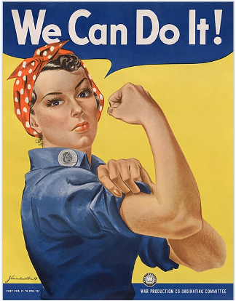
Appendix
Figure 1

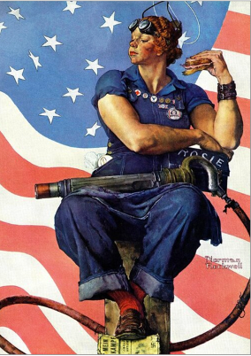
Figure 2
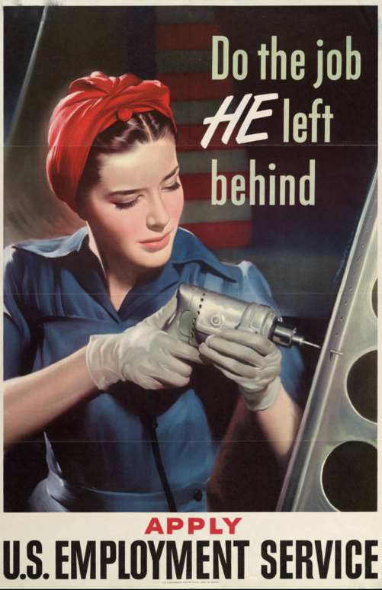
Figure 3

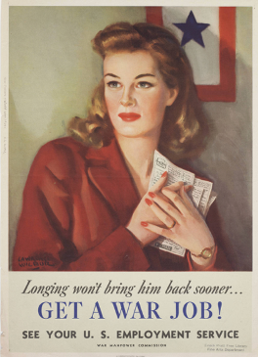
Figure 4
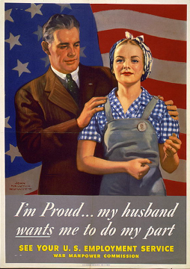
Figure 5

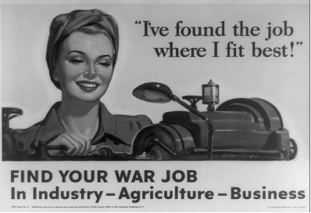
Figure 6

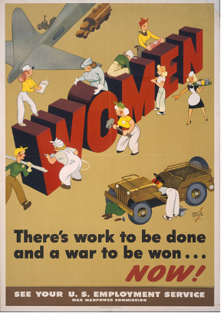
Figure 7

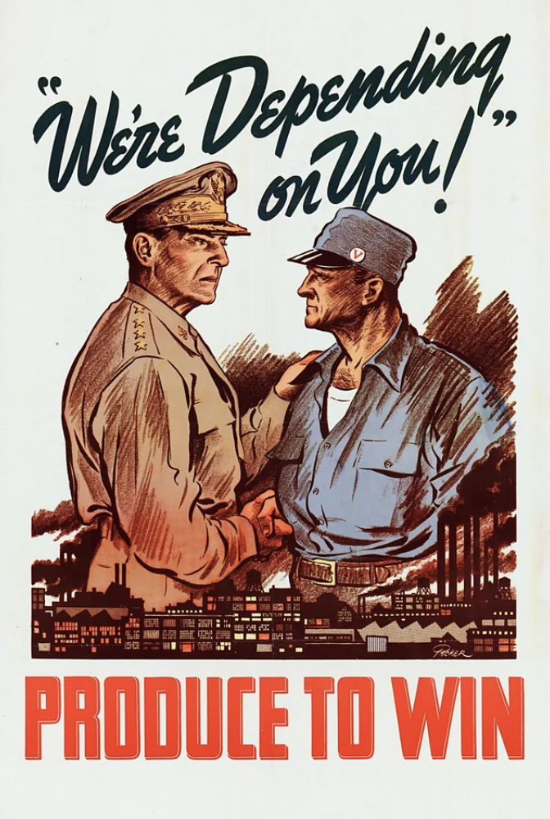
Figure 8
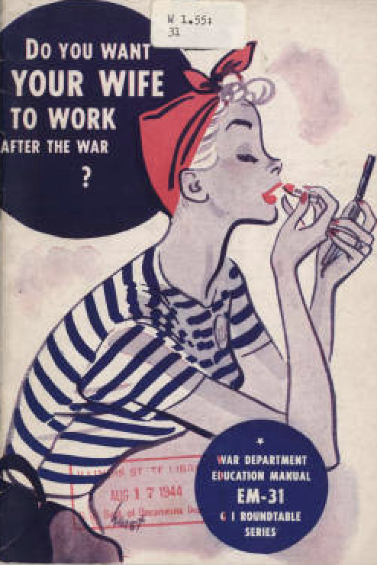
Figure 9

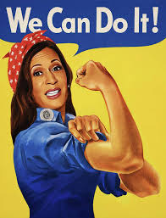
Figure 10
Bibliography
Primary Sources

American Historical Association. Do You Want Your Wife to Work After the War? G. I. Roundtable Series, EM31. Circa 1944. Illinois State Library. Illinois Digital Archives. Accessed August 19, 2025. http://www.idaillinois.org/digital/collection/isl3/id/12759.

Furnas, J. C. “Are Women Doing Their Share in the War?” Saturday Evening Post 216, no. 44 (April 29, 1944): 12–44. https://research.ebsco.com/linkprocessor/plink?id=2513207f-c3ad-3f95-80fc-4a5f618ca7db.

Grant, Vernon, artist. Women: There's Work to Be Done and a War to Be Won ... Now! See Your U.S. Employment Service. Washington, D.C.: U.S. Government Printing Office for the United States War Manpower Commission and Office of War Information, 1944. Photograph. https://www.loc.gov/item/97515648/.

Harris, P. G.. 1943."Do the job he left behind: apply U.S. Employment Service." University of Minnesota Libraries, Upper Midwest Literary Archives., Accessed November 06, 2025. https://umedia.lib.umn.edu/item/p16022coll208:4553.

Howitt, John Newton, artist. I'm Proud ... My Husband Wants Me to Do My Part: See Your U.S. Employment Service. Washington, D.C.: U.S. Government Printing Office for the United States War Manpower Commission and the United States Office of War Information, 1944. Photograph. https://www.loc.gov/item/95504753/.

Ickes, Harold L. “Watch out for the Women.” Saturday Evening Post 215, no. 34 (February 20, 1943): 19–79. https://research.ebsco.com/linkprocessor/plink?id=319b1692-cf51-3780-870b-6b9971b27e05.

"I've found the job where I fit best!" find your war job in industry, agriculture, business/ / George R. United States, 1943. Washington, D.C.: Office of War Information. Photograph. https://www.loc.gov/item/90707072/.

Miller, J. Howard. Rosie the Riveter. 1942. Poster. National Museum of American History. Smithsonian Institution. Washington, DC.

“Mr. Rosie.” Saturday Evening Post 216, no. 7 (August 14, 1943): 4. https://research.ebsco.com/linkprocessor/plink?id=7e91d5af-c8ce-362e-b477-210b5504374f.

Nicko Prints. “Kamala Harris as Rosie the Riveter on the We Can Do It famous WW2 poster — Art Print.” Nicko Prints. Accessed November 7, 2025. https://nickoprints.com/featured/kamala-harris-as-rosie-the-riveter-on-the-we-can-do-it-famous-ww2-poster-nicko-prints.html?product=art-print.

Packer, Fred Little. We’re Depending on You! Produce to Win. Office for Emergency Management, War Production Board, ca. 1942. Poster. Library of Congress. https://www.loc.gov/pictures/item/90714997/.

Rockwell, Norman. Rosie the Riveter Post Cover. May 29, 1943.

Thompson, Dorothy. "The Stake of Women in Full Postwar Employment." Ladies' Home Journal, 04, 1944, 6-6, 183, https://login.proxy048.nclive.org/login?url=https://www.proquest.com/magazines/stake-women-full-postwar-employment/docview/1926466082/se-2.

Wilbur, Lawrence. Longing Won’t Bring Him Back Sooner… Get a War Job! See Your U.S. Employment Service. Washington, D.C.: U.S. Government Printing Office, 1944. Poster. War Manpower Commission. New York Historical Society Library.

Secondary Sources

Anderson, Karen. Wartime Women: Sex Roles, Family Relations, and the Status of Women During World War II. Greenwood Press, 1981.

Berger, John. Ways of Seeing. Penguin Books, 2008.

Bhattacharya, Tithi, ed. Social Reproduction Theory: Remapping Class, Recentering Oppression. Pluto Press, 2017. https://doi.org/10.2307/j.ctt1vz494j.

Dumenil, Lynn. “The New Woman and the Politics of the 1920s.” OAH Magazine of History 21, no. 3 (2007): 22–26. http://www.jstor.org/stable/25162125.

Federici, Silvia. “Social Reproduction Theory: History, Issues and Present Challenges.” Radical Philosophy, no. 204 (Spring 2019): 55–57. https://www.radicalphilosophy.com/article/social-reproduction-theory-2#:~:text=Silvia%20Federici%20has%20written%20about%20social%20reproduction,Enclosure%2C%20Commons%2C%20and%20the%20Global%20Fishermen's%20Movement*.

Fellows, Erwin W. “‘Propaganda:’ History of a Word.” American Speech 34, no. 3 (1959): 182–89. https://doi.org/10.2307/454039.

Gluck, Sherna Berger. Rosie the Riveter Revisited: Women, the War, and Social Change. New York: Plume, 1988.

Gold, David and Jessica Enoch, eds. Women at Work: Rhetorics of Gender and Labor. University of Pittsburgh Press, 2019. https://doi.org/10.2307/j.ctvn96hfp.

Goldin, Claudia, and Claudia Olivetti. “Shocking Labor Supply: A Reassessment of the Role of World War II on Women’s Labor Supply.” The American Economic Review 103, no. 3 (2013): 257–62. http://www.jstor.org/stable/23469739.

Harrington, Sara. “Women’s Work: Domestic Labor in American World War II Posters.” Art Documentation: Journal of the Art Libraries Society of North America 22, no. 2 (2003): 41–44. http://www.jstor.org/stable/27949264.

Honey, Maureen. Creating Rosie the Riveter: Class, Gender, and Propaganda during World War II. University of Massachusetts Press, 1984.

Kennedy, David M. Freedom from Fear: The American People in Depression and War, 1929-1945. New York: Oxford University Press, 1999.

Kimble, James J., and Lester C. Olson. “Visual Rhetoric Representing Rosie the Riveter: Myth and Misconception in J. Howard Miller’s ‘We Can Do It!’ Poster.” Rhetoric and Public Affairs 9, no. 4 (2006): 533–69. http://www.jstor.org/stable/41940102.

Knaff, Donna B. Beyond Rosie the Riveter: Women of World War II in American Popular Graphic Art. Lawrence: University Press of Kansas, 2012.

Kossoudji, Sherrie A., and Laura J. Dresser. “Working Class Rosies: Women Industrial Workers during World War II.” The Journal of Economic History 52, no. 2 (1992): 431–46. http://www.jstor.org/stable/2123119.

Lerner, Gerda. “Placing Women in History: Definitions and Challenges.” Feminist Studies 3, no. 1/2 (1975): 5–14. https://doi.org/10.2307/3518951.

Mahaney, Darlene C. “Propaganda Posters.” OAH Magazine of History 16, no. 3 (2002): 41–46. http://www.jstor.org/stable/25163525.

National WWI Museum and Memorial. “Service Flag.” TheWorldWar.org. Accessed December 8, 2025. https://www.theworldwar.org/learn/about-wwi/service-flag.

Rupp, Leila J. Mobilizing Women for War: German and American Propaganda, 1939-1945. Princeton University Press, 1978. http://www.jstor.org/stable/j.ctt13x1cs7.

Schweitzer, Mary M. “World War II and Female Labor Force Participation Rates.” The Journal of Economic History 40, no. 1 (1980): 89–95. http://www.jstor.org/stable/2120427.

Scott, Joan W. “Gender: A Useful Category of Historical Analysis.” The American Historical Review 91, no. 5 (1986): 1053–75. https://doi.org/10.2307/1864376.

Tilly, Louise A. “Gender, Women’s History, and Social History.” Social Science History 13, no. 4 (1989): 439–62. https://doi.org/10.2307/1171222.

David M. Kennedy, Freedom from Fear: The American People in Depression and War, 1929-1945, New York: Oxford University Press, 1999, 776.
Mary M. Schweitzer, “World War II and Female Labor Force Participation Rates,” The Journal of Economic History 40, no. 1 (1980): 90.
Schweitzer, 90.
Schweitzer, 90.
See Sherna Berger Gluck, Rosie the Riveter Revisited: Women, the War, and Social Change, Plume, 1988; and James J. Kimble and Lester C. Olson, “Visual Rhetoric Representing Rosie the Riveter: Myth and Misconception in J. Howard Miller’s ‘We Can Do It!’ Poster,” Rhetoric and Public Affairs, no. 4 (2006).
Kimble and Olson, “Visual Rhetoric Representing Rosie the Riveter: Myth and Misconception in J. Howard Miller’s ‘We Can Do It!’ Poster,” 534.
Note that the historiographical section of this paper has been significantly condensed per the requirements of the journal. As a result, here are the references to other scholars whose work directly relates to discussions presented in this paper. Donna B. Knaff, Beyond Rosie the Riveter: Women of World War II in American Popular Graphic Art (University Press of Kansas, 2012): 2-3; Leila J. Rupp, Mobilizing Women for War: German and American Propaganda, 1939-1945 (Princeton University Press, 1978), 138 and see poster references on 154 and 158; Michelle Smith, “In Rosie’s Shadow: World War II Recruitment Rhetoric and Women’s Work in Public Memory,” in Women’s Work: Rhetorics of Gender and Labor, ed. David Gold and Jessica Enoch (University of Pittsburgh Press, 2019), 187.
Louise A. Tilly, “Gender, Women’s History, and Social History,” Social Science History 13, no. 4 (1989): 451-452.
Joan W. Scott, “Gender: A Useful Category of Historical Analysis,” The American Historical Review 91, no. 5 (1986): 1067.
Scott, 1068.
Scott, 1068.
Scott, 1072.
Scott, 1072-1074.
Lynn Dumenil, “The New Woman and the Politics of the 1920s,” OAH Magazine of History 21, no. 3 (2007): 22-24.
Dumenil, “The New Woman and the Politics of the 1920s,” 23.
Gluck, Rosie the Riveter Revisited: Women, the War, and Social Change, 4.
Gluck, 7.
Gluck, 8.
Gluck, 9.
Gluck, 9.
Silvia Federici, “Social Reproduction Theory: History, Issues, and Present Challenges,” Radical Philosophy, no. 204 (Spring 2019): 55.
Tithi Bhattacharya and Lise Vogel, “Introduction: Mapping Social Reproduction Theory,” in Social Reproduction Theory: Remapping Class, Recentering Oppression, ed. Tithi Bhattacharya (London: Pluto Press, 2017), 2.
Bhattacharya and Vogel, “Introduction: Mapping Social Reproduction Theory,” 2.
John Berger, Ways of Seeing (Penguin Books, 2008), 11.
Berger, Ways of Seeing (Penguin Books, 2008), 46.
Norman Rockwell, Rosie the Riveter Post Cover, May 29, 1943.
Berger, 47.
Smith, 188.
Darlene C. Mahaney, “Propaganda Posters,” OAH Magazine of History 16, no. 3 (2002): 41.
P. G. Harris, “Do the Job He Left Behind: Apply U.S. Employment Service,” 1943, University of Minnesota Libraries, Upper Midwest Literary Archives, accessed November 6, 2025.
Lawrence Wilbur, Longing Won’t Bring Him Back Sooner… Get a War Job! See Your U.S. Employment Service (U.S. Government Printing Office for the War Manpower Commission, 1944), poster, New-York Historical Society Library.
Wilbur, Longing Won’t Bring Him Back Sooner… Get a War Job! See Your U.S. Employment Service.
National WWI Museum and Memorial, “Service Flag,” TheWorldWar.org, accessed December 8, 2025.
John Newton Howitt, I’m Proud … My Husband Wants Me to Do My Part: See Your U.S. Employment Service (U.S. Government Printing Office for the United States War Manpower Commission and the United States Office of War Information, 1944), photograph, Library of Congress.
“I’ve Found the Job Where I Fit Best!” Find Your War Job in Industry, Agriculture, Business (Office of War Information, 1943), photograph, Library of Congress.
“I’ve Found the Job Where I Fit Best!” Find Your War Job in Industry, Agriculture, Business.
“I’ve Found the Job Where I Fit Best!” Find Your War Job in Industry, Agriculture, Business.
Gluck, 10-11.
Vernon Grant, Women: There’s Work to Be Done and a War to Be Won … Now! See Your U.S. Employment Service (U.S. Government Printing Office for the United States War Manpower Commission and Office of War Information, 1944), photograph, Library of Congress.
Grant, Women: There’s Work to Be Done and a War to Be Won … Now! See Your U.S. Employment Service.
Grant, Women: There’s Work to Be Done and a War to Be Won … Now! See Your U.S. Employment Service.
Fred Little Packer, We’re Depending on You! Produce to Win (Office for Emergency Management and War Production Board, ca. 1942), poster, Library of Congress. This image is currently on display at the Library of Congress so digital access can be done through Reddit under “Propaganda Posters.”
Packer, We’re Depending on You! Produce to Win.
Claudia Goldin and Claudia Olivetti, “Shocking Labor Supply: A Reassessment of the Role of World War II on Women’s Labor Supply,” 257.
Schweitzer, 90.
Gluck, 13.
Harold L. Ickes, “Watch Out for the Women,” Saturday Evening Post 215, no. 34 (February 20, 1943): 19.
Ickes, “Watch Out for the Women,” 79.
“Mr. Rosie,” Saturday Evening Post 216, no. 7 (August 14, 1943): 4.
“Mr. Rosie,” 4.
“Mr. Rosie,” 4.
J. C. Furnas, “Are Women Doing Their Share in the War?” Saturday Evening Post 216, no. 44 (April 29, 1944): 12-13.
Furnas, “Are Women Doing Their Share in the War?,” 13.
Dorothy Thompson, “The Stake of Women in Full Postwar Employment,” Ladies’ Home Journal, (April 1944): 6.
Thompson, “The Stake of Women in Full Postwar Employment,” 6.
Schweitzer, 90.
Schweitzer, 90.
Schweitzer, 90.
American Historical Association, Do You Want Your Wife to Work After the War? G.I. Roundtable Series, EM31 (ca. 1944), Illinois State Library, Illinois Digital Archives, accessed August 19, 2025: 2 and 37.
American Historical Association, Do You Want Your Wife to Work After the War?, 37.
American Historical Association, 37.
American Historical Association, 38.
Nicko Prints, “Kamala Harris as Rosie the Riveter on the We Can Do It famous WW2 poster—Art Print,” Nicko Prints, accessed November 7, 2025.

